

# **MCA Semester – III Front End Development Project**

|  |  |
| --- | --- |
| **Name** | **Fraron Pirooz Balsara** |
| **USN** | **211VMTR00242** |
| **Elective** | **Full Stack Development** |
| **Date of submission** | **16/03/2023** |



# **Front End Development Project**

Project Report submitted to Jain Online (Deemed-to-be University as part of the course "Front End Development Project"

**Master of Computer Applications**

Submitted by

Mr. Fraron Pirooz Balsara

USN

211VMTR00242

Under the guidance of

Ms. Priti Rahul Sekhsaria

# **DECLARATION**

I, Mr. Fraron Pirooz Balsara, hereby declare that this Project Report has been prepared by me under the guidance of Ms. Priti Rahul Sekhsaria. I declare that this Project is towards the partial fulfillment of the credit requirement for the course “Front End Development Project,” which is part of the Master of Computer Applications degree given by Jain University, Bengaluru. I declare that the work done by me towards this Project is original in nature and is my own contribution.

Name: Fraron Pirooz Balsara

USN: 211VMTR00242

Place: Mumbai

Date: 16-03-2023

# **CERTIFICATE**

This is to certify that the Project report submitted by Mr. Fraron Pirooz Balsara bearing  
USN: 211VMTR00242 on the title “Front End Development Project” is a record of project work done by him during the academic year 2022-23 under my guidance and supervision in partial fulfilment of Master of Computer Applications.

----------------------

Place: Mumbai

Date: 16-03-2023

# **ACKNOWLEDGEMENT**

Foremost, I would like to express my sincere gratitude to my advisor Ms. Priti Rahul Sekhsaria for the continuous support during project development, for her patience, motivation, enthusiasm and immense knowledge. Her guidance helped me throughout the process of development of this project. I cannot imagine having a better mentor for my project.

Besides my advisor I would like to thank all the previous professors who taught us HTML, CSS and JavaScript. They taught me the fundamentals really well which helped me throughout the development of this project. Having completed their classes and course made this project simpler for me.

Finally, I’d like to thank my fellow classmates for the stimulating discussions, constant encouragement and for all the fun and support throughout the process.

# **TABLE OF CONTENTS**

|  |  |
| --- | --- |
| **TITLE** | **PAGE NO.** |
| Executive Summary | 7 |
| Introduction | 8-9 |
| Objectives | 10-11 |
| Project Description | 12-13 |
| Future Enhancements | 14 |
| Flowchart | 15 |
| Page Layout Diagrams | 16-20 |
| Code | 21-74 |
| Output - Screenshots | 75-80 |
| Validation | 81 |
| Conclusion | 82 |
| References and Bibliography | 83-84 |

# **EXECUTIVE SUMMARY**

Spring Flowers School web application is a specialized type of Content Management System (CMS) that can be accessed by most electronic devices by accessing the internet. Once developed the client (Spring Flowers School) is in charge of the web application and updating the content. Users can only access the web application and cannot make any changes to it.

The website enables new users to gain more information about the school and its culture. It gives them a brief insight into the day to day working of the school and what to expect from the school. It allows new users to view images of the school and helps them better understand what the school is like and how it functions. This information allows new users to remotely make an educated decision regarding their admission to the school without having to show up on campus in-person.

Registered students can additionally use the web application to gain additional information like their time-table, exam-results and their own profile information. This enables students to access information online and reduce the work load of the school office staff of conducting these tasks offline. Having a web application also helps the school extend their reach to geographically dispersed students. It also helps the school centralise data, reduce offline tasks and encourage online interaction in a world that is rapidly growing online. The web application enables self-help as the students can help themselves by retrieving whatever information they require at any time, even during odd non-working hours of the school office.

On launching the web application, the user is presented with the Home page. A navbar on the top enables users to navigate to Time Table, Exam Results and Extracurricular Activities pages and view and interact with the information they seek. Additionally, the navbar also has a Profile section from where the student can view their respective profile information.

Anyone from anywhere can access the web application provided they have an internet connection. The web application can be accessed from mobile devices, tablets, laptops and even desktop computers. It is designed to be responsive in nature and adjust to the user’s screens size, ensuring an engaging experience.

# **INTRODUCTION**

## **Problem Statement – 1**

Student Management

Spring Flower School wants to create an online portal for their students.

1. As a student, I should be able to see the welcome page of the application.
2. As a student, I should be able to see a Navigation bar and School logo in the welcome page.
3. The Navigation bar should contain Time Table, Exam Results, Extracurricular Activities and Student Profile

Use HTML5 and CSS3

## **Problem Statement – 2**

Student Management

Spring Flowers school wants to create a online portal for their students.

User Stories:-

1. As a student, I should be able to see my Time Table in a new web page after clicking the timetable button.
2. As a student, I should be able to see my Information in a new web page after clicking the Student Profile Button.

Use HTML5 and CSS3

## **Problem Statement – 3**

Student Management

Spring Flowers school wants to create a online portal for their students.

User Stories:-

1. As a student, I should be able to see login page as a first page. In the login page, I should be able to enter my user name and password and click on the login button.
2. As a student, I should be able to see the Welcome page only if the student is valid.
3. As a Student, I should be able to see my name on the top of the application on every page once I have logged in the application.
4. As a student, I should be able to see the grades of a student in a new webpage after clicking the exam results button. Subject should be selected from the drop box.
5. As a student, I should be able to enter the extra activities I have done for the day in a new page after clicking the Extra Activity Button. Once submitted I should be able to see the activity on the page.

Use HTML5, CSS3 and JavaScript

## **Problem Statement – 4**

Student Management

Spring Flowers school wants to create a online portal for their students.

User Stories:-

1. Multiple users should be able to login to the application with different username and password for each user. (Minimum 3)
2. The grade for each user must be different and should be displayed on the exam result page, when clicked.
3. The Student Profile page should display the student profile according to the user that has logged in.

Instructions:-

Use HTML5, CSS3 and JavaScript. Use JSON file instead of Arrays.

# **OBJECTIVES**

## **Problem Statement – 1**

1. A responsive web application needs to be created for Spring Flowers School that can be accessed on any device.
2. The web application should have a home page that should be created with a welcome message for students and other users. When a user first accesses the web application they will view this home page.
3. The home page should be created with a navbar and a school logo. The navbar can be placed on top of the home page and a school logo needs to be deigned and displayed as well.
4. The navbar created should have Time Table, Exam Results, Extracurricular Activities and Student Profile options to navigate between.

## **Problem Statement – 2**

1. The responsive web application created in the previous problem statement needs to be enhanced.
2. The web application should have a time table page that displays a class time table for the student. This should be accessible through the Time Table section of the navbar.
3. The web application should also have a Profile page where registered users can view their profile details. This should be available through Student Profile section in the navbar.

## **Problem Statement – 3**

1. The responsive web application created in the previous problem statement needs to be enhanced.
2. The web application should have a login page as its landing page and only registered users should be allowed to access the application after they have successfully logged in.
3. Users should also be able to see their username on every page of the website.
4. Exam Results should be displayed in the Exam Results page of the web application which is accessible through the navbar. Students should only be able to view their own results.
5. An extracurricular activities page needs to be created that is accessible through the navbar and allows students to add activities and displays them in the same page.

## **Problem Statement – 4**

1. The responsive web application created in the previous problem statement needs to be enhanced.
2. Multiple users should be able to login to the website using their respective credentials.
3. On logging the username of that particular user should be displayed on the top in the navbar.
4. In the Exam Results page the grades should be displayed based on the user that is logged in.
5. The student Profile page should display data based on the user that is logged in.

# **PROJECT DESCRIPTION**

## **Problem Statement – 1**

1. A home page with a welcome message was created that the user can view on launching the web application. The home page contained a navbar, welcome message, school image, about us section, school statistics, information regarding why to join the school, information on school’s achievements, an image gallery, testimonials from students and a footer with the school’s contact information.
2. The navbar contains a logo that was designed from scratch along with the ability to navigate between home page, time table page, exam results page, extracurricular activities page and student profile page.
3. A web page/application was created using HTML5, CSS3 and Bootstrap. HTML was used for the structure, text and media insertion. CSS was used for design, styling, decoration and fine tuning. Bootstrap was used to make the web page/application responsive.

## **Problem Statement – 2**

1. A time table page was created to display the current time table for users. Additionally, download and print buttons were created to allow users to download or print the time table according to their convenience.
2. A profile page was created for registered users to view their profile information, program manager information and academic information.
3. The web pages were created using HTML5, CSS3, JavaScript and Bootstrap. HTML was used for the structure, text and media insertion. CSS was used for design, styling, decoration, media queries and fine tuning. JavaScript was used to perform actions on button clicks. Bootstrap was used to make the web page/application responsive.

## **Problem Statement – 3**

1. The home page is replaced with a newly created login page as our index.html file. Users now land on the login page first and have to login successfully to access the home page.
2. Once logged in, the user is able to view their username in the top right-hand corner in the navbar on every page.
3. Exam Results page was created that allows students to view their exam results using the website.
4. An Extracurricular Activities page was created that allows users to activities which are then displayed in the same page in an orderly manner.
5. The web pages were created using HTML5, CSS3, JavaScript and Bootstrap. HTML was used for the structure, text and media insertion. CSS was used for design, styling, decoration, media queries and fine tuning. JavaScript was used to perform actions on button clicks. Bootstrap was used to make the web page/application responsive.

## **Problem Statement – 4**

1. Multiple different users were created and their data was added in student-data.json file.
2. Each user can login using their credentials to access/view their respective exam results in the Exam Results page of the application.
3. Each user can login using their credentials to access/view their respective profile information in the Profile page of the application.
4. Each user can login using their credentials to access/view their respective time table in the Time Table page of the application.
5. Additionally, after logging in the username of the user is displayed in the navbar on top of each page.
6. The web pages were created using HTML5, CSS3, JavaScript, Bootstrap and JSON. HTML was used for the structure, text and media insertion. CSS was used for design, styling, decoration, media queries and fine tuning. JavaScript was used to perform actions on button clicks. Bootstrap was used to make the web page/application responsive. JSON was used to input unique data for each user in the Time Table, Exam Results and Profile pages of the application.

# **FUTURE ENHANCEMENTS**

There are several possible future enhancements to the Spring Flowers School web application. Some of them are listed below:-

1. An accounting system can be created for the Spring Flowers Office Staff to conduct accounts online in line with the Accounting Policy.
2. Online admission form submissions can be enabled/created so that students can apply online with all their information and submit soft copies of their respective documents in a safe and secure manner. This helps students apply for admission from anywhere and also helps the school maintain a centralised and secure data centre for student’s personal documents.
3. An online attendance system can be created for students and teachers alike eliminating the need for manual attendance.
4. A module can be added for a laboratory inventory management system. Spring Flowers School has several important laboratories whose inventory is bring managed manually.
5. Everything is moving online since the corona virus outbreak. It is important to be ready in case a situation arises where exams need to be held online. An exam module can also be integrated with the web application allowing the school to conduct online examinations if required.

# **FLOWCHART**

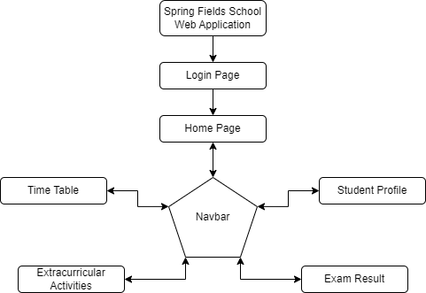

# **PAGE LAYOUT DIAGRAMS**

Login Page:-

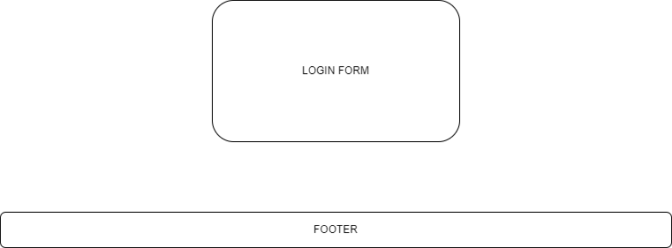

Home Page:-

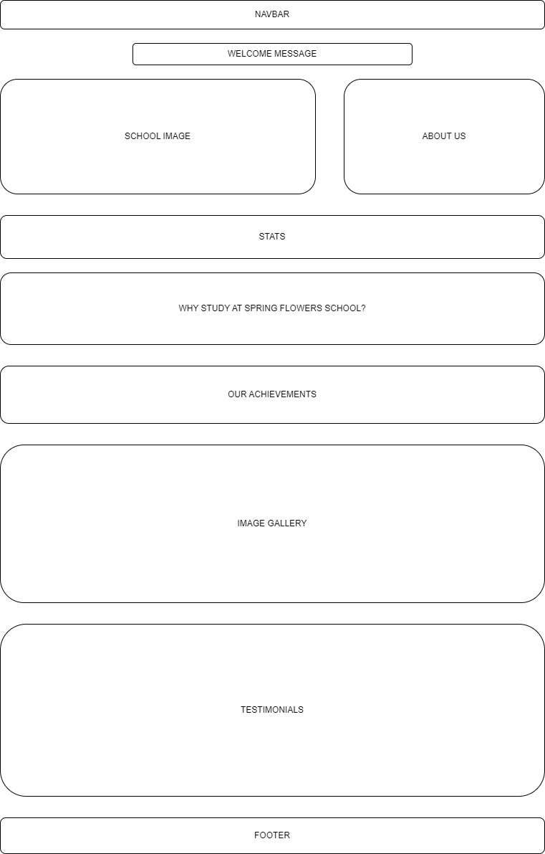

Time Table Page:-

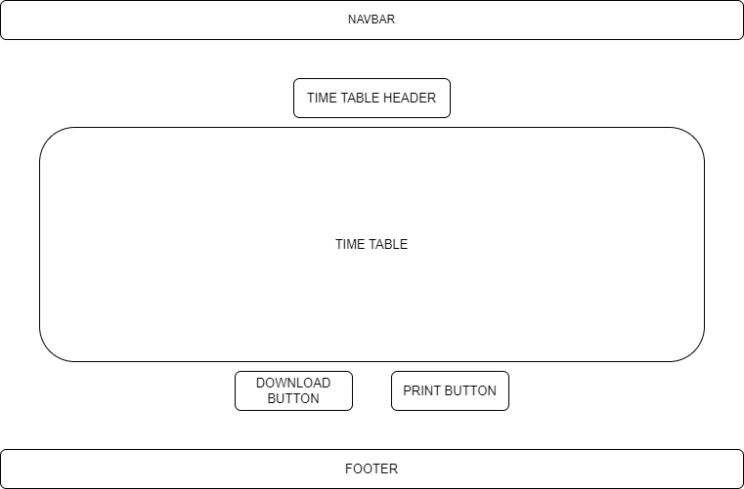

Exam Results page:-

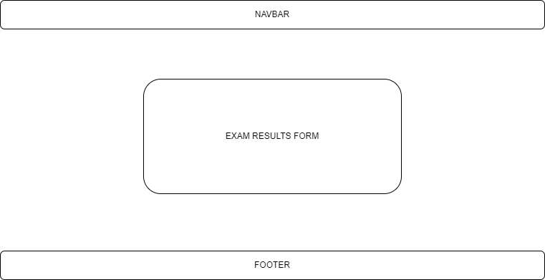

Extracurricular Activities page:-

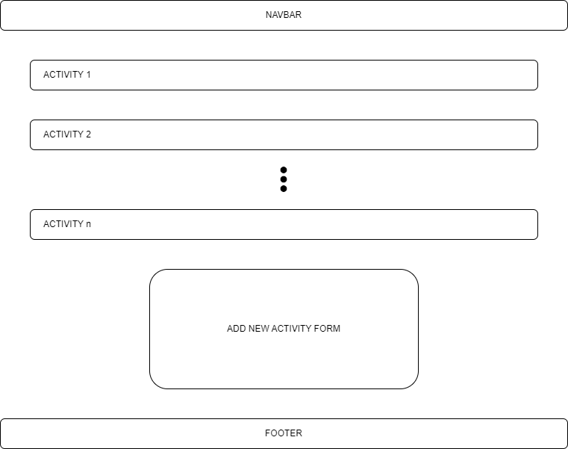

Profile Page:-

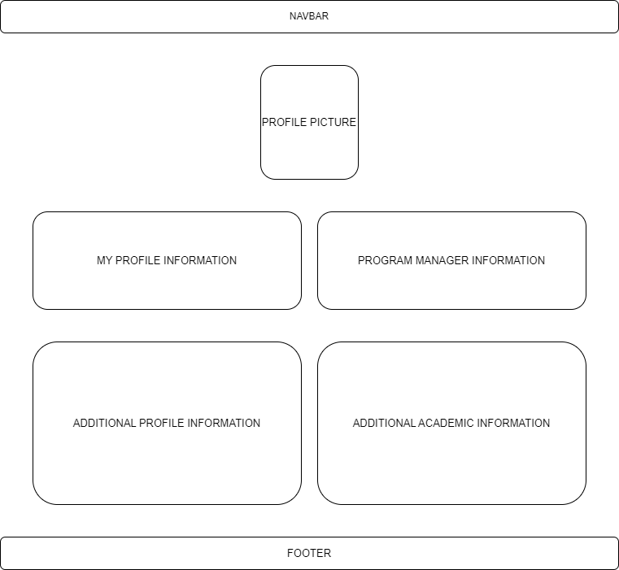

# **CODING**

index.html

<html lang="en">

  <head>

    <meta charset="utf-8">

    <meta name="viewport" content="width=device-width, initial-scale=1">

    <title>Login - Spring Flowers School</title>

    <link rel="icon" type="image/png" href="../img/favicon.png">

    <link rel="stylesheet" href="../css/index.css">

    <link href="https://cdn.jsdelivr.net/npm/bootstrap@5.3.0-alpha1/dist/css/bootstrap.min.css" rel="stylesheet" integrity="sha384-GLhlTQ8iRABdZLl6O3oVMWSktQOp6b7In1Zl3/Jr59b6EGGoI1aFkw7cmDA6j6gD" crossorigin="anonymous">

  </head>

  <body class="d-flex flex-column min-vh-100">

    <!--Bootstrap Script-->

    <script src="https://cdn.jsdelivr.net/npm/bootstrap@5.3.0-alpha1/dist/js/bootstrap.bundle.min.js" integrity="sha384-w76AqPfDkMBDXo30jS1Sgez6pr3x5MlQ1ZAGC+nuZB+EYdgRZgiwxhTBTkF7CXvN" crossorigin="anonymous"></script>

    <!--JavaScript File-->

    <script type="text/javascript" src="../js/index.js"></script>

    <main class="container">

      <!--LOGIN SECTION START-->

      <div class="d-flex flex-column align-items-center justify-content-center" style="min-height: 80vh;">

        <div id="background-div" class="col-lg-5 text-center">

          <img id="navbar_brand_logo" src="../img/navbar_logo.png" class="img-fluid" alt="Spring Flower School Logo">

          <form method="post" onsubmit="return login();">

            <br>

            <div class="form-class">

              <input class="form-control" type="text" id="username" minlength="4" maxlength="20" pattern="[a-zA-Z][a-zA-Z ]+" placeholder="Username" required>

              <small id="username-help" class="text-muted">Must be alphabets only and 4-20 characters long.</small>

            </div>

            <br>

            <div class="form-class">

              <input class="form-control" type="password" id="password" minlength="8" maxlength="20" placeholder="Password" autocomplete="off" required>

              <small id="password-help" class="text-muted">Must be 8-20 characters long.</small>

            </div>

            <br>

            <div id="login-error">!!! Inavlid username or password !!!</div>

            <button class="btn btn-light" type="submit">Login</button>

          </form>

        </div>

      </div>

      <!--LOGIN SECTION END-->

    </main>

    <!--FOOTER START-->

    <footer class="mt-auto">

      <div id="footer-div" class="text-center">

        Phone: (000)000-0000 | (000)000-0001

        <br>Email: admissions@springflowers.com

        <br>Location: 221B, Baker Street, London, United Kingdom

        <br>2023 &#169 Spring Flowers School - Copyright All Rights Reserved

      </div>

    </footer>

    <!--FOOTER END-->

  </body>

</html>

index.css

body{

    background-image: url("../img/background-image.jpg") !important;

    background-size: cover !important;

    background-repeat: no-repeat !important;

    background-position: center center !important;

    background-attachment: fixed !important;

    font-family: cursive !important;

}

.empty-space{

    padding-top: 50px;

}

#navbar_brand_logo{

    width: 200px;

    height: 50px;

}

#background-div{

    background-color: #ffdac0;

    border-radius:20px;

    padding: 30px 30px 15px 30px;

}

.form-class{

    text-align: left;

}

#login-error{

    margin-bottom: 20px;

    color: red;

    display: none;

}

.btn{

    border: 2px solid black !important;

}

#footer-div{

    background-color: #ffdac0;

    padding-bottom: 15px;

    padding-top: 15px;

}

index.js

let student = [];

function fetchStudentData(){

    fetch("../json/student-data.json").then((response) => response.json()).then((json) => {

        student = JSON.parse(JSON.stringify(json)).student;

    });

}

fetchStudentData();

function login(){

    let entered_username = document.getElementById("username").value;

    let entered_password = document.getElementById("password").value;

    let valid_user = false;

    for(let i = 0; i < student.length; i++){

        if(entered_username == student[i].username && entered_password == student[i].password){

            valid_user = true;

            sessionStorage.setItem('username', student[i].username);

            sessionStorage.setItem('id', student[i].id);

            break;

        }

    }

    if(valid_user){

        window.location.href="../html/home.html";

        return false;

    }

    else{

        document.getElementById("login-error").style.display = "block";

        return false;

    }

}

home.html

<!doctype html>

<html lang="en">

  <head>

    <meta charset="utf-8">

    <meta name="viewport" content="width=device-width, initial-scale=1">

    <title>Home - Spring Flowers School</title>

    <link rel="icon" type="image/png" href="../img/favicon.png">

    <link rel="stylesheet" href="../css/home.css">

    <link href="https://cdn.jsdelivr.net/npm/bootstrap@5.3.0-alpha1/dist/css/bootstrap.min.css" rel="stylesheet" integrity="sha384-GLhlTQ8iRABdZLl6O3oVMWSktQOp6b7In1Zl3/Jr59b6EGGoI1aFkw7cmDA6j6gD" crossorigin="anonymous">

  </head>

  <body class="d-flex flex-column min-vh-100">

    <!--Bootstrap Script-->

    <script src="https://cdn.jsdelivr.net/npm/bootstrap@5.3.0-alpha1/dist/js/bootstrap.bundle.min.js" integrity="sha384-w76AqPfDkMBDXo30jS1Sgez6pr3x5MlQ1ZAGC+nuZB+EYdgRZgiwxhTBTkF7CXvN" crossorigin="anonymous"></script>

    <!--NAVBAR START-->

    <nav class="navbar navbar-custom navbar-expand-lg sticky-top">

      <div class="container-fluid">

        <a class="navbar-brand nav-link disabled" href="#">

          <img id="navbar_brand_logo" src="../img/navbar_logo.png" class="img-fluid" alt="Spring Flower School Logo">

        </a>

        <button class="navbar-toggler" type="button" data-bs-toggle="collapse" data-bs-target="#navbarSupportedContent" aria-controls="navbarSupportedContent" aria-expanded="false" aria-label="Toggle navigation">

          <span class="navbar-toggler-icon"></span>

        </button>

        <div class="collapse navbar-collapse" id="navbarSupportedContent">

          <ul class="navbar-nav me-auto mb-2 mb-lg-0">

            <li class="nav-item">

              <a class="nav-link active" aria-current="page" href="home.html">Home</a>

            </li>

            <li class="nav-item">

              <a class="nav-link" href="time-table.html">Time Table</a>

            </li>

            <li class="nav-item">

              <a class="nav-link" href="exam-result.html">Exam Result</a>

            </li>

            <li class="nav-item">

              <a class="nav-link" href="extracurricular-activities.html">Extracurricular Activities</a>

            </li>

          </ul>

          <!--- SEARCH BAR NOT REQUIRED FOR NOW

          <form class="d-flex ms-auto" role="search">

            <input class="form-control me-2" type="search" placeholder="Search" aria-label="Search">

            <button class="btn btn-outline-success" type="submit">Search</button>

          </form>

          -->

          <ul class="navbar-nav ms-auto mb-2 mb-lg-0">

            <li class="nav-item dropdown">

              <a class="nav-link dropdown-toggle" href="#" role="button" data-bs-toggle="dropdown" aria-expanded="false" id="student-username">

                <img id="student_profile_pic_image" src="../img/profile_pic_icon.jpg">

                Student Name Placeholder

              </a>

              <ul class="dropdown-menu">

                <li><a class="dropdown-item" href="profile.html">Profile</a></li>

                <li><a class="dropdown-item disabled" href="#">Change Password</a></li>

                <li><hr class="dropdown-divider"></li>

                <li><a class="dropdown-item" href="index.html" onclick="logout()">Logout</a></li>

              </ul>

            </li>

          </ul>

        </div>

      </div>

    </nav>

    <!--NAVBAR END-->

    <!--HEADER STARTS-->

    <header>

      <div id="school-title" class="text-center">

        <h1>Welcome to Spring Flowers School</h1>

        <h6>Your future is waiting for you.</h6>

      </div>

    </header>

    <!--HEADER ENDS-->

    <main class="container">

      <!--(SCHOOL IMAGE + ABOUT US) START-->

      <div id="school-image-about-us" class="row">

        <div id="school-image-div" class="col-lg-7  text-center">

          <img id="school-image" src="../img/Spring-Flower-School-Image.jpg" class="img-fluid" alt="Spring Flowers School Image">

          <figcaption>Spring Flowers School</figcaption>

        </div>

        <div id="about-us" class="col text-left">

          <h2>About Us</h2>

          <p>

            Spring Flowers School is one of the country's largest and most diverse school with more than 250,000 alumni. Founded in 1923 with the goal to foster excellence, we provide people from all backgrounds with the opportunity to acquire the skills, knowledge and experience to succeed at whatever they choose to do.

          </p>

          <p>

            As one of the country's largest and most progressive schools, our teaching, research and partnerships are characterised by a focus on real world impact - addressing the health, economic and social challenges facing society today.

            Our passion for increasing access to education and mobilising the collective power and expertise of the federation is central to our ability to transform lives around the world and address the global challenges of the future.

          </p>

        </div>

      </div>

      <!--(SCHOOL IMAGE + ABOUT US) END-->

      <div class="empty-space"></div>

      <!--STATS START-->

      <div id="stats" class="row">

        <div class="col text-center">

          <h3>24</h3>

          <h6>Courses Offered</h6>

        </div>

        <div class="col text-center">

          <h3>2,527</h3>

          <h6>Students Currently<br>Enrolled</h6>

        </div>

        <div class="col text-center">

          <h3>52</h3>

          <h6>Faculty Members</h6>

        </div>

        <div class="col text-center">

          <h3>1,200</h3>

          <h6>Average SAT Score</h6>

        </div>

      </div>

      <!--STATS END-->

      <div class="empty-space"></div>

      <!--WHY STUDY HERE? START-->

      <div id="why-study-here" class="text-left">

        <h2>Why study at Spring Flowers School?</h2>

        <ul id=custom-list>

          <li>Professors and lecturers aren’t just teachers – they’re mentors too. For students to see and understand the paths their professors have been on to get where they are today can be both inspiring and valuable.</li>

          <li>It’s important to encourage students to learn from their mistakes and view them as an opportunity to improve. A lot of the time, setbacks and ‘failure’ can be the catalyst for future success as lessons are learnt.</li>

          <li>While students are equipped with the tools and theories necessary to deal with and overcome the challenges of everyday life, they’re also encouraged to identify their strengths and characteristics and how they can best use them.</li>

          <li>Providing hands-on learning opportunities and getting students out into the real world to achieve greatness.</li>

          <li>Teaching and learning should always be relevant – whether it’s related to your course or extra-curricular activities. While Spring Flowers School teaches its students necessary workplace skills, it also teaches them about the importance of wellbeing, and proposes positive practices, including how to manage emotions, how to engage in the communities, how to have positive relations with others and most critically, how to have meaning in life.</li>

        </ul>

      </div>

      <!--WHY STUDY HERE? END-->

      <div class="empty-space"></div>

      <!--OUR ACHIEVEMENTS START-->

      <div id="our-achievements" class="text-left">

        <h2>Our Achievements</h2>

        <ul id=custom-list>

          <li>Ranked number 1 for student satisfaction, student voice and academic support - National Student Survey</li>

          <li>School of the Year for Student Experience - The Times</li>

          <li>In top 10% of the schools in the country - The Guardian</li>

          <li>70%+ of our research is rated world-leading - Framework For Excellent Research (FFER)</li>

        </ul>

      </div>

      <!--OUR ACHIEVEMENTS END-->

      <div class="empty-space"></div>

      <!--CAROUSEL START-->

      <div id="demo" class="carousel slide" data-bs-ride="carousel">

        <h2>Image Gallery</h2>

        <!-- Indicators/dots -->

        <div class="carousel-indicators">

          <button type="button" data-bs-target="#demo" data-bs-slide-to="0" class="active"></button>

          <button type="button" data-bs-target="#demo" data-bs-slide-to="1"></button>

          <button type="button" data-bs-target="#demo" data-bs-slide-to="2"></button>

          <button type="button" data-bs-target="#demo" data-bs-slide-to="3"></button>

          <button type="button" data-bs-target="#demo" data-bs-slide-to="4"></button>

          <button type="button" data-bs-target="#demo" data-bs-slide-to="5"></button>

          <button type="button" data-bs-target="#demo" data-bs-slide-to="6"></button>

          <button type="button" data-bs-target="#demo" data-bs-slide-to="7"></button>

          <button type="button" data-bs-target="#demo" data-bs-slide-to="8"></button>

          <button type="button" data-bs-target="#demo" data-bs-slide-to="9"></button>

          <button type="button" data-bs-target="#demo" data-bs-slide-to="10"></button>

          <button type="button" data-bs-target="#demo" data-bs-slide-to="11"></button>

        </div>

        <!-- The slideshow/carousel -->

        <div class="carousel-inner">

          <div class="carousel-item active">

            <img src="../img/1.jpg" alt="img1" class="d-block w-100">

          </div>

          <div class="carousel-item">

            <img src="../img/2.jpg" alt="img2" class="d-block w-100">

          </div>

          <div class="carousel-item">

            <img src="../img/3.jpg" alt="img3" class="d-block w-100">

          </div>

          <div class="carousel-item">

            <img src="../img/4.jpg" alt="img4" class="d-block w-100">

          </div>

          <div class="carousel-item">

            <img src="../img/5.jpg" alt="img5" class="d-block w-100">

          </div>

          <div class="carousel-item">

            <img src="../img/6.jpg" alt="img6" class="d-block w-100">

          </div>

          <div class="carousel-item">

            <img src="../img/7.jpg" alt="img7" class="d-block w-100">

          </div>

          <div class="carousel-item">

            <img src="../img/8.jpg" alt="img8" class="d-block w-100">

          </div>

          <div class="carousel-item">

            <img src="../img/9.jpg" alt="img9" class="d-block w-100">

          </div>

          <div class="carousel-item">

            <img src="../img/10.jpg" alt="img10" class="d-block w-100">

          </div>

          <div class="carousel-item">

            <img src="../img/11.jpg" alt="img11" class="d-block w-100">

          </div>

          <div class="carousel-item">

            <img src="../img/12.jpg" alt="img12" class="d-block w-100">

          </div>

        </div>

        <!-- Left and right controls/icons -->

        <button class="carousel-control-prev" type="button" data-bs-target="#demo" data-bs-slide="prev">

          <span class="carousel-control-prev-icon"></span>

        </button>

        <button class="carousel-control-next" type="button" data-bs-target="#demo" data-bs-slide="next">

          <span class="carousel-control-next-icon"></span>

        </button>

      </div>

      <!--CAROUSEL END-->

      <div class="empty-space"></div>

      <!--TESTIMONIALS START-->

      <div id="testimonial-div">

        <h2>Student Testimonials</h2>

        <div class="testimonial">

          <blockquote>The Spring Flowers School played an integral part in making me the person that I am today. The combination of caring staff, dedicated faculty, and inspiring peers from all over the world showed me how to think with an open mind, and apply that understanding of diversity to everything I do. The values and skills that I was taught here through the IB program made me feel more confident in myself, especially when it came to pursuing my higher education abroad. Looking back, I am proud to say that I am an alumnus of SFS.</blockquote>

          <div></div>

          <h6 class="testimonial-owner">Hans Brown, Software Engineer and Team Lead at Amazon, Class of 2000.</h6>

        </div>

        <div class="testimonial">

          <blockquote>Personally, I felt that the best part about Spring Flowers School was its diversity. While I did not realize it initially, the diverse environment created by the people who come from various backgrounds has taught me a lot. It taught me about other cultures and helped me learn more about all the various people who live in our world. Such knowledge is incredibly beneficial in a more globalized world and personally it has helped me overcome cultural barriers outside school.</blockquote>

          <div></div>

          <h6 class="testimonial-owner">Katelynn Metz, Studies Bio-Chemistry at Columbia University, Class of 2020.</h6>

        </div>

        <div class="testimonial">

          <blockquote>Spring Flowers School is a school that upholds its core values in every area of school life, inside and outside the classroom. Students and teachers are given a safe environment to voice their thoughts, be creative, collaborate, and be who they are. It is a school where Professional Development plays a vital role in helping students develop new ideas, and keeping up with new educational best practices. Spring Flowers School is wonderful, warm, welcoming and exciting school to study in.</blockquote>

          <div></div>

          <h6 class="testimonial-owner">Karen Kessler, Studies Law at Harward University, Class of 2017.</h6>

        </div>

        <div class="testimonial">

          <blockquote>Spring Flowers School gives opportunities and exposure to all of its students in various fields. In my growth as a leader, the school played a pivotal role. I express my deepest gratitude to my teachers who have guided and moulded me and helped me realise and showcase my talents giving me the perfect foundation to build my career.</blockquote>

          <div></div>

          <h6 class="testimonial-owner">Richie Hegmann, CEO at Techno Inc., Class of 2008.</h6>

        </div>

        <div class="testimonial">

          <blockquote>I joined the Spring Flow School mid-way through the academic year and was quite apprehensive about how I would adjust. However, a pleasant surprise lay in store for me and the multi-cultural environment and wonderful teachers enabled me to assimilate very quickly. I look back fondly at my brief but memorable years at Spring Flowers School which helped cement my foundation for my career. Thank You Spring Flowers School.</blockquote>

          <div></div>

          <h6 class="testimonial-owner">June Tremblay, Doctor of Medicine at John Hopkins Hospital, Class of 2012.</h6>

        </div>

      </div>

      <!--TESTIMONIALS END-->

    </main>

    <div class="empty-space"></div>

    <!--FOOTER START-->

    <footer class="mt-auto">

      <div id="footer-div" class="text-center">

        Phone: (000)000-0000 | (000)000-0001

        <br>Email: admissions@springflowers.com

        <br>Location: 221B, Baker Street, London, United Kingdom

        <br>2023 &#169 Spring Flowers School - Copyright All Rights Reserved

      </div>

    </footer>

    <!--FOOTER END-->

    <!--SETTING USERNAME IN NAVBAR-->

    <script>document.getElementById("student-username").innerHTML = '<img id="student_profile_pic_image" src="../img/profile_pic_icon.jpg"> '.concat(sessionStorage.getItem("username"));</script>

  </body>

</html>

home.css

body{

    background-image: url("../img/background-image.jpg") !important;

    background-size: cover !important;

    background-repeat: no-repeat !important;

    background-position: center center !important;

    background-attachment: fixed !important;

    font-family: cursive !important;

}

.empty-space{

    padding-top: 50px;

}

.navbar-custom{

    background-color: #ffdac0;

}

#navbar_brand_logo{

    width: 200px;

    height: 50px;

}

/*ul.navbar-nav li:hover{

      border-radius: 30px !important;

      background-color: #ff90a8 !important;

}*/

.navbar-nav .active{

    text-decoration: underline wavy !important;

}

.dropdown-menu{

    background-color: #FDFDF9 !important;

}

.dropdown-item:hover{

    background-color: #ffdac0 !important;

}

.dropdown-item:active{

    background-color: #ffdac0 !important;

    color: black !important;

}

#student_profile_pic_image{

    height: 25px;

    width: 25px;

    padding-bottom: 3px;

}

#school-title{

    padding-top: 15px;

    padding-bottom: 15px;

}

#school-image-about-us{

    background-color: #ffdac0;

    border-radius: 20px;

    padding-top: 15px;

}

#school-image-div{

    padding-bottom: 30px;

}

#school-image{

    height: 100%;

    width: 100%;

    border-radius: 20px;

}

#about-us{

    padding-top: 10px;

    padding-bottom: 30px;

}

#stats{

    background-color: #ffdac0;

    border-radius: 20px;

    padding-top: 10px;

}

#why-study-here{

    background-color: #ffdac0;

    border-radius: 20px;

    padding-top: 15px;

    padding-bottom: 1px;

    padding-left: 15px;

    padding-right: 15px;

}

#our-achievements{

    background-color: #ffdac0;

    border-radius: 20px;

    padding-top: 15px;

    padding-bottom: 1px;

    padding-left: 15px;

    padding-right: 15px;

}

#demo{

    background-color: #ffdac0;

    border-radius: 20px;

    padding-top: 15px;

    padding-bottom: 15px;

    padding-left: 15px;

    padding-right: 15px;

}

.d-block{

    max-height: 500px;

}

#custom-list{

    position: relative;

    list-style: none;

    padding-left: 32.5px;

}

#custom-list li:before{

    content: "\2192 \0020";

    position: absolute;

    left: 0;

    padding-left: 12.5px;

}

#testimonial-div{

    background-color: #ffdac0;

    border-radius: 20px;

    padding-top: 15px;

    padding-bottom: 15px;

    padding-left: 15px;

    padding-right: 15px;

}

blockquote::before{

    content: "“";

    font-family: 'Times New Roman', Times, serif;

    font-size: large;

}

blockquote::after{

    content: "”";

    font-family: 'Times New Roman', Times, serif;

    font-size: large;

}

.testimonial blockquote {

    margin: 10px 10px 0;

    background: #f4fafc;

    padding: 20px 60px;

    position: relative;

    border: none;

    border-radius: 8px;

    font-style: italic;

}

.testimonial blockquote:before,

.testimonial blockquote:after {

    content: "\201C";

    position: absolute;

    font-size: 80px;

    line-height: 1;

    color: #757f9a;

    font-style: normal;

}

.testimonial blockquote:before {

    top: 0;

    left: 10px;

}

.testimonial blockquote:after {

    content: "\201D";

    right: 10px;

    bottom: -0.5em;

}

.testimonial div {

    width: 0;

    height: 0;

    border-left: 0 solid transparent;

    border-right: 20px solid transparent;

    border-top: 20px solid #f4fafc;

    margin: 0 0 0 60px;

    bottom: -0.5em;

}

.testimonial p {

    margin: 8px 0 0 20px;

    text-align: left;

    color: #fff;

}

.testimonial-owner{

    margin-left: 15px;

}

#footer-div{

    background-color: #ffdac0;

    padding-bottom: 15px;

    padding-top: 15px;

}

time-table.html

<html lang="en">

  <head>

    <meta charset="utf-8">

    <meta name="viewport" content="width=device-width, initial-scale=1">

    <title>Time Table - Spring Flowers School</title>

    <link rel="icon" type="image/png" href="../img/favicon.png">

    <link rel="stylesheet" href="../css/time-table.css">

    <link rel="stylesheet" href="../css/print.css" type="text/css" media="print">

    <link href="https://cdn.jsdelivr.net/npm/bootstrap@5.3.0-alpha1/dist/css/bootstrap.min.css" rel="stylesheet" integrity="sha384-GLhlTQ8iRABdZLl6O3oVMWSktQOp6b7In1Zl3/Jr59b6EGGoI1aFkw7cmDA6j6gD" crossorigin="anonymous">

  </head>

  <body class="d-flex flex-column min-vh-100">

    <!--Bootstrap Script-->

    <script src="https://cdn.jsdelivr.net/npm/bootstrap@5.3.0-alpha1/dist/js/bootstrap.bundle.min.js" integrity="sha384-w76AqPfDkMBDXo30jS1Sgez6pr3x5MlQ1ZAGC+nuZB+EYdgRZgiwxhTBTkF7CXvN" crossorigin="anonymous"></script>

    <!--Icon library-->

    <link rel="stylesheet" href="https://cdnjs.cloudflare.com/ajax/libs/font-awesome/4.7.0/css/font-awesome.min.css">

    <!--Button Scripts-->

    <script type="text/javascript" src="https://cdnjs.cloudflare.com/ajax/libs/pdfmake/0.1.22/pdfmake.min.js"></script>

    <script type="text/javascript" src="https://cdnjs.cloudflare.com/ajax/libs/html2canvas/0.4.1/html2canvas.min.js"></script>

    <script type="text/javascript" src="../js/time-table.js"></script>

    <nav class="navbar navbar-custom navbar-expand-lg sticky-top">

        <div class="container-fluid">

          <a class="navbar-brand nav-link disabled" href="#">

            <img id="navbar_brand_logo" src="../img/navbar_logo.png" class="img-fluid" alt="Spring Flower School Logo">

          </a>

          <button class="navbar-toggler" type="button" data-bs-toggle="collapse" data-bs-target="#navbarSupportedContent" aria-controls="navbarSupportedContent" aria-expanded="false" aria-label="Toggle navigation">

            <span class="navbar-toggler-icon"></span>

          </button>

          <div class="collapse navbar-collapse" id="navbarSupportedContent">

            <ul class="navbar-nav me-auto mb-2 mb-lg-0">

              <li class="nav-item">

                <a class="nav-link" href="home.html">Home</a>

              </li>

              <li class="nav-item">

                <a class="nav-link active" aria-current="page" href="time-table.html">Time Table</a>

              </li>

              <li class="nav-item">

                <a class="nav-link" href="exam-result.html">Exam Result</a>

              </li>

              <li class="nav-item">

                <a class="nav-link" href="extracurricular-activities.html">Extracurricular Activities</a>

              </li>

            </ul>

            <!--- SEARCH BAR NOT REQUIRED FOR NOW

            <form class="d-flex ms-auto" role="search">

              <input class="form-control me-2" type="search" placeholder="Search" aria-label="Search">

              <button class="btn btn-outline-success" type="submit">Search</button>

            </form>

            -->

            <ul class="navbar-nav ms-auto mb-2 mb-lg-0">

              <li class="nav-item dropdown">

                <a class="nav-link dropdown-toggle" href="#" role="button" data-bs-toggle="dropdown" aria-expanded="false" id="student-username">

                  <img id="student_profile_pic_image" src="../img/profile_pic_icon.jpg">

                  Student Name Placeholder

                </a>

                <ul class="dropdown-menu">

                  <li><a class="dropdown-item" href="profile.html">Profile</a></li>

                  <li><a class="dropdown-item disabled" href="#">Change Password</a></li>

                  <li><hr class="dropdown-divider"></li>

                  <li><a class="dropdown-item" href="index.html">Logout</a></li>

                </ul>

              </li>

            </ul>

          </div>

        </div>

    </nav>

    <!--NAVBAR END-->

    <div class="empty-space"></div>

    <main class="container">

      <!--TIME TBALE START-->

      <div class="table-responsive text-center">

        <h2>TIME TABLE</h2>

        <table class="table print" id="time-table">

          <thead class="table-primary">

            <tr>

              <th scope="col">Period/Time</th>

              <th scope="col">Monday</th>

              <th scope="col">Tuesday</th>

              <th scope="col">Wednesday</th>

              <th scope="col">Thursday</th>

              <th scope="col">Friday</th>

            </tr>

          </thead>

          <tbody class="table-secondary">

            <tr>

              <th scope="row" class="table-primary">1. 08:30-08:45</th>

              <td colspan="5" class="text-center table-info">Assembly</td>

            </tr>

            <tr>

              <th scope="row" class="table-primary">2. 08:45-09:45</th>

              <td id="mon1">Science</td>

              <td id="tue1">Political Science</td>

              <td id="wed1">Geography</td>

              <td id="thu1">Math</td>

              <td id="fri1">English Literature</td>

            </tr>

            <tr>

              <th scope="row" class="table-primary">3. 09:45-10:45</th>

              <td id="mon2">Social Studies</td>

              <td id="tue2">Information Technology</td>

              <td id="wed2">Science</td>

              <td id="thu2">Geography</td>

              <td id="fri2">Political Science</td>

            </tr>

            <tr>

              <th scope="row" class="table-primary">4. 10:45-11:00</th>

              <td colspan="5" class="text-center table-info">Short Break</td>

            </tr>

            <tr>

              <th scope="row" class="table-primary">5. 11:00-12:00</th>

              <td id="mon3">Information Technology</td>

              <td id="tue3">English Literature</td>

              <td id="wed3">Math</td>

              <td id="thu3">Art & Crafts</td>

              <td id="fri3">Physical Education</td>

            </tr>

            <tr>

              <th scope="row" class="table-primary">6. 12:00-13:00</th>

              <td id="mon4">Math</td>

              <td id="tue4">Math</td>

              <td id="wed4">Political Science</td>

              <td id="thu4">Social Studies</td>

              <td id="fri4">Information Technology</td>

            </tr>

            <tr>

              <th scope="row" class="table-primary">7. 13:00-13:30</th>

              <td colspan="5" class="text-center table-info">Long Break</td>

            </tr>

            <tr>

              <th scope="row" class="table-primary">8. 13:30-14:30</th>

              <td id="mon5">Geography</td>

              <td id="tue5">Science</td>

              <td id="wed5">English Literature</td>

              <td id="thu5">Physical Education</td>

              <td id="fri5">Science</td>

            </tr>

          </tbody>

        </table>

        <!--BUTTONS START-->

        <button class="btn" onclick="Download()"><i class="fa fa-download"></i> Download</button>

        <button class="btn" onclick="window.print();return false;"><i class="fa fa-print"></i> Print</button>

        <!--BUTTONS END-->

      </div>

      <!--TIME TBALE END-->

    </main>

    <div class="empty-space"></div>

    <!--FOOTER START-->

    <footer class="mt-auto">

      <div id="footer-div" class="text-center">

        Phone: (000)000-0000 | (000)000-0001

        <br>Email: admissions@springflowers.com

        <br>Location: 221B, Baker Street, London, United Kingdom

        <br>2023 &#169 Spring Flowers School - Copyright All Rights Reserved

      </div>

    </footer>

    <!--FOOTER END-->

    <!--SETTING USERNAME-->

    <script>document.getElementById("student-username").innerHTML = '<img id="student_profile_pic_image" src="../img/profile_pic_icon.jpg"> '.concat(sessionStorage.getItem("username"));</script>

  </body>

</html>

time-table.css

body{

    background-image: url("../img/background-image.jpg") !important;

    background-size: cover !important;

    background-repeat: no-repeat !important;

    background-position: center center !important;

    background-attachment: fixed !important;

    font-family: cursive !important;

}

.empty-space{

    padding-top: 50px;

}

.navbar-custom{

    background-color: #ffdac0;

}

#navbar_brand_logo{

    width: 200px;

    height: 50px;

}

.navbar-nav .active{

    text-decoration: underline wavy !important;

}

.dropdown-menu{

    background-color: #FDFDF9 !important;

  }

.dropdown-item:hover{

    background-color: #ffdac0 !important;

}

.dropdown-item:active{

    background-color: #ffdac0 !important;

    color: black !important;

}

#student_profile_pic_image{

    height: 25px;

    width: 25px;

    padding-bottom: 3px;

}

.table-responsive{

    background-color: #ffdac0;

    border-radius: 20px;

    padding: 15px;

}

table, th, td{

    border: 2px solid black !important;

}

table{

    padding-top: 8px;

}

.btn{

    background-color: black !important;

    color: white !important;

    height: 40px !important;

    width: 115px !important;

    border: none !important;

    margin: 10px !important;

    cursor: pointer !important

}

.btn:hover {

    background-color: rgb(51, 51, 51) !important;

}

#footer-div{

    background-color: #ffdac0;

    padding-bottom: 15px;

    padding-top: 15px;

}

time-table.js

//Download button function

function Download() {

    html2canvas(document.getElementById('time-table'), {

        onrendered: function (canvas) {

            var data = canvas.toDataURL();

            var docDefinition = {

                content: [{

                    image: data,

                    width: 500

                }]

            };

            pdfMake.createPdf(docDefinition).download("Time-Table.pdf");

        }

    });

}

//Display time-table subjects according to student

let student = [];

function fetchTimeTableData(){

    fetch("../json/student-data.json").then((response) => response.json()).then((json) => {

        student = JSON.parse(JSON.stringify(json)).student;

        callDisplayTimeTableData();

    });

}

fetchTimeTableData();

function callDisplayTimeTableData(){

    let mon1 = document.getElementById("mon1");

    let mon2 = document.getElementById("mon2");

    let mon3 = document.getElementById("mon3");

    let mon4 = document.getElementById("mon4");

    let mon5 = document.getElementById("mon5");

    let tue1 = document.getElementById("tue1");

    let tue2 = document.getElementById("tue2");

    let tue3 = document.getElementById("tue3");

    let tue4 = document.getElementById("tue4");

    let tue5 = document.getElementById("tue5");

    let wed1 = document.getElementById("wed1");

    let wed2 = document.getElementById("wed2");

    let wed3 = document.getElementById("wed3");

    let wed4 = document.getElementById("wed4");

    let wed5 = document.getElementById("wed5");

    let thu1 = document.getElementById("thu1");

    let thu2 = document.getElementById("thu2");

    let thu3 = document.getElementById("thu3");

    let thu4 = document.getElementById("thu4");

    let thu5 = document.getElementById("thu5");

    let fri1 = document.getElementById("fri1");

    let fri2 = document.getElementById("fri2");

    let fri3 = document.getElementById("fri3");

    let fri4 = document.getElementById("fri4");

    let fri5 = document.getElementById("fri5");

    for(let i = 0; i < student.length; i++){

        if(student[i].id == sessionStorage.getItem("id")){

            mon1.innerHTML = student[i].time_table[0]["mon1"];

            mon2.innerHTML = student[i].time_table[0]["mon2"];

            mon3.innerHTML = student[i].time_table[0]["mon3"];

            mon4.innerHTML = student[i].time_table[0]["mon4"];

            mon5.innerHTML = student[i].time_table[0]["mon5"];

            tue1.innerHTML = student[i].time_table[0]["tue1"];

            tue2.innerHTML = student[i].time_table[0]["tue2"];

            tue3.innerHTML = student[i].time_table[0]["tue3"];

            tue4.innerHTML = student[i].time_table[0]["tue4"];

            tue5.innerHTML = student[i].time_table[0]["tue5"];

            wed1.innerHTML = student[i].time_table[0]["wed1"];

            wed2.innerHTML = student[i].time_table[0]["wed2"];

            wed3.innerHTML = student[i].time_table[0]["wed3"];

            wed4.innerHTML = student[i].time_table[0]["wed4"];

            wed5.innerHTML = student[i].time_table[0]["wed5"];

            thu1.innerHTML = student[i].time_table[0]["thu1"];

            thu2.innerHTML = student[i].time_table[0]["thu2"];

            thu3.innerHTML = student[i].time_table[0]["thu3"];

            thu4.innerHTML = student[i].time_table[0]["thu4"];

            thu5.innerHTML = student[i].time_table[0]["thu5"];

            fri1.innerHTML = student[i].time_table[0]["fri1"];

            fri2.innerHTML = student[i].time_table[0]["fri2"];

            fri3.innerHTML = student[i].time_table[0]["fri3"];

            fri4.innerHTML = student[i].time_table[0]["fri4"];

            fri5.innerHTML = student[i].time_table[0]["fri5"];

        }

    }

}

exam-result.html

<html lang="en">

  <head>

    <meta charset="utf-8">

    <meta name="viewport" content="width=device-width, initial-scale=1">

    <title>Exam Result - Spring Flowers School</title>

    <link rel="icon" type="image/png" href="../img/favicon.png">

    <link rel="stylesheet" href="../css/exam-result.css">

    <link href="https://cdn.jsdelivr.net/npm/bootstrap@5.3.0-alpha1/dist/css/bootstrap.min.css" rel="stylesheet" integrity="sha384-GLhlTQ8iRABdZLl6O3oVMWSktQOp6b7In1Zl3/Jr59b6EGGoI1aFkw7cmDA6j6gD" crossorigin="anonymous">

  </head>

  <body class="d-flex flex-column min-vh-100">

    <!--Bootstrap Script-->

    <script src="https://cdn.jsdelivr.net/npm/bootstrap@5.3.0-alpha1/dist/js/bootstrap.bundle.min.js" integrity="sha384-w76AqPfDkMBDXo30jS1Sgez6pr3x5MlQ1ZAGC+nuZB+EYdgRZgiwxhTBTkF7CXvN" crossorigin="anonymous"></script>

    <!--JavaScript File-->

    <script type="text/javascript" src="../js/exam-result.js"></script>

    <!--NAVBAR START-->

    <nav class="navbar navbar-custom navbar-expand-lg sticky-top">

        <div class="container-fluid">

          <a class="navbar-brand nav-link disabled" href="#">

            <img id="navbar_brand_logo" src="../img/navbar_logo.png" class="img-fluid" alt="Spring Flower School Logo">

          </a>

          <button class="navbar-toggler" type="button" data-bs-toggle="collapse" data-bs-target="#navbarSupportedContent" aria-controls="navbarSupportedContent" aria-expanded="false" aria-label="Toggle navigation">

            <span class="navbar-toggler-icon"></span>

          </button>

          <div class="collapse navbar-collapse" id="navbarSupportedContent">

            <ul class="navbar-nav me-auto mb-2 mb-lg-0">

              <li class="nav-item">

                <a class="nav-link" href="home.html">Home</a>

              </li>

              <li class="nav-item">

                <a class="nav-link" href="time-table.html">Time Table</a>

              </li>

              <li class="nav-item">

                <a class="nav-link active" aria-current="page" href="exam-result.html">Exam Result</a>

              </li>

              <li class="nav-item">

                <a class="nav-link" href="extracurricular-activities.html">Extracurricular Activities</a>

              </li>

            </ul>

            <!--- SEARCH BAR NOT REQUIRED FOR NOW

            <form class="d-flex ms-auto" role="search">

              <input class="form-control me-2" type="search" placeholder="Search" aria-label="Search">

              <button class="btn btn-outline-success" type="submit">Search</button>

            </form>

            -->

            <ul class="navbar-nav ms-auto mb-2 mb-lg-0">

              <li class="nav-item dropdown">

                <a class="nav-link dropdown-toggle" href="#" role="button" data-bs-toggle="dropdown" aria-expanded="false" id="student-username">

                  <img id="student_profile_pic_image" src="../img/profile_pic_icon.jpg">

                  Student Name Placeholder

                </a>

                <ul class="dropdown-menu">

                  <li><a class="dropdown-item" href="profile.html">Profile</a></li>

                  <li><a class="dropdown-item disabled" href="#">Change Password</a></li>

                  <li><hr class="dropdown-divider"></li>

                  <li><a class="dropdown-item" href="index.html">Logout</a></li>

                </ul>

              </li>

            </ul>

          </div>

        </div>

    </nav>

    <!--NAVBAR END-->

    <div class="empty-space"></div>

    <main class="container">

      <!--EXAM-RESULTS START-->

      <div class="d-flex flex-column align-items-center justify-content-center" style="min-height: 55vh;">

        <div class="col-lg-7 text-center" id="form-div">

          <h5 id="exam-result-header">End Semester Exam Results - January 2023</h5>

          <form>

            <select class="form-select text-center form-class" id="subject" onchange="displayMarks()">

              <option selected>--- Select Subject ---</option>

              <option id="subject1" value="English Literature">English Literature</option>

              <option id="subject2" value="Science">Science</option>

              <option id="subject3" value="Math">Math</option>

              <option id="subject4" value="Information Technology">Information Technology</option>

              <option id="subject5" value="Social Studies">Social Studies</option>

              <option id="subject6" value="Political Science">Political Science</option>

              <option id="subject7" value="Geography">Geography</option>

              <option value="Overall">Overall</option>

            </select>

            <div class="input-group form-class">

              <span class="input-group-text">Marks</span>

              <input type="text" class="form-control" id="marks" readonly>

            </div>

            <div class="input-group form-class">

              <span class="input-group-text">Grade</span>

              <input type="text" class="form-control" id="grade" readonly>

            </div>

          </form>

        </div>

      </div>

      <!--EXAM-RESULTS END-->

    </main>

    <!--FOOTER START-->

    <footer class="mt-auto">

      <div id="footer-div" class="text-center">

        Phone: (000)000-0000 | (000)000-0001

        <br>Email: admissions@springflowers.com

        <br>Location: 221B, Baker Street, London, United Kingdom

        <br>2023 &#169 Spring Flowers School - Copyright All Rights Reserved

      </div>

    </footer>

    <!--FOOTER END-->

    <!--SETTING USERNAME IN NAVBAR-->

    <script>document.getElementById("student-username").innerHTML = '<img id="student_profile_pic_image" src="../img/profile_pic_icon.jpg"> '.concat(sessionStorage.getItem("username"));</script>

  </body>

</html>

exam-result.css

body{

    background-image: url("../img/background-image.jpg") !important;

    background-size: cover !important;

    background-repeat: no-repeat !important;

    background-position: center center !important;

    background-attachment: fixed !important;

    font-family: cursive !important;

}

.empty-space{

    padding-top: 50px;

}

.navbar-custom{

    background-color: #ffdac0;

}

#navbar_brand_logo{

    width: 200px;

    height: 50px;

}

.navbar-nav .active{

    text-decoration: underline wavy !important;

}

.dropdown-menu{

    background-color: #FDFDF9 !important;

  }

.dropdown-item:hover{

    background-color: #ffdac0 !important;

}

.dropdown-item:active{

    background-color: #ffdac0 !important;

    color: black !important;

}

#student_profile_pic_image{

    height: 25px;

    width: 25px;

    padding-bottom: 3px;

}

#form-div{

    background-color: #ffdac0;

    border-radius:20px;

    padding: 30px 30px 15px 30px;

}

#exam-result-header{

    margin-bottom: 15px;

}

.form-class{

    margin-bottom: 15px;

}

#footer-div{

    background-color: #ffdac0;

    padding-bottom: 15px;

    padding-top: 15px;

}

exam-result.js

let student = [];

//To display subjects in the select tag

function fetchSubjects(){

    fetch("../json/student-data.json").then((response) => response.json()).then((json) => {

        student = JSON.parse(JSON.stringify(json)).student;

        callDisplaySubjects();

    });

}

fetchSubjects();

function callDisplaySubjects(){

    let subject1 = document.getElementById("subject1");

    let subject2 = document.getElementById("subject2");

    let subject3 = document.getElementById("subject3");

    let subject4 = document.getElementById("subject4");

    let subject5 = document.getElementById("subject5");

    let subject6 = document.getElementById("subject6");

    let subject7 = document.getElementById("subject7");

    for(let i = 0; i < student.length; i++){

        if(student[i].id == sessionStorage.getItem("id")){

            subject1.innerHTML = student[i].subjects_selection[0]["subject1"];

            subject1.value = student[i].subjects_selection[0]["subject1"];

            subject2.innerHTML = student[i].subjects_selection[0]["subject2"];

            subject2.value = student[i].subjects_selection[0]["subject2"];

            subject3.innerHTML = student[i].subjects_selection[0]["subject3"];

            subject3.value = student[i].subjects_selection[0]["subject3"];

            subject4.innerHTML = student[i].subjects_selection[0]["subject4"];

            subject4.value = student[i].subjects_selection[0]["subject4"];

            subject5.innerHTML = student[i].subjects_selection[0]["subject5"];

            subject5.value = student[i].subjects_selection[0]["subject5"];

            subject6.innerHTML = student[i].subjects_selection[0]["subject6"];

            subject6.value = student[i].subjects_selection[0]["subject6"];

            subject7.innerHTML = student[i].subjects_selection[0]["subject7"];

            subject7.value = student[i].subjects_selection[0]["subject7"];

        }

    }

}

//To populate marks and grade

function displayMarks(){

    fetch("../json/student-data.json").then((response) => response.json()).then((json) => {

        student = JSON.parse(JSON.stringify(json)).student;

        callDisplayMarks();

    });

}

function callDisplayMarks(){

    let subject = document.getElementById("subject").value;

    let marks = document.getElementById("marks");

    let grade = document.getElementById("grade");

    for(let i = 0; i < student.length; i++){

        if(student[i].id == sessionStorage.getItem("id")){

            for(let j = 0; j < student[i].exam_results.length; j++){

                for(const key in student[i].exam_results[j]){

                    if(student[i].exam_results[j].hasOwnProperty(key)){

                        if(subject == key){

                            marks.value = student[i].exam_results[j][key][0]["marks"];

                            grade.value = student[i].exam_results[j][key][0]["grade"];

                        }

                    }

                }

            }

        }

    }

}

extracurricular-activities.html

<html lang="en">

  <head>

    <meta charset="utf-8">

    <meta name="viewport" content="width=device-width, initial-scale=1">

    <title>Extracurricular Activities - Spring Flowers School</title>

    <link rel="icon" type="image/png" href="../img/favicon.png">

    <link rel="stylesheet" href="../css/extracurricular-activities.css">

    <link href="https://cdn.jsdelivr.net/npm/bootstrap@5.3.0-alpha1/dist/css/bootstrap.min.css" rel="stylesheet" integrity="sha384-GLhlTQ8iRABdZLl6O3oVMWSktQOp6b7In1Zl3/Jr59b6EGGoI1aFkw7cmDA6j6gD" crossorigin="anonymous">

  </head>

  <body class="d-flex flex-column min-vh-100">

    <!--Bootstrap Script-->

    <script src="https://cdn.jsdelivr.net/npm/bootstrap@5.3.0-alpha1/dist/js/bootstrap.bundle.min.js" integrity="sha384-w76AqPfDkMBDXo30jS1Sgez6pr3x5MlQ1ZAGC+nuZB+EYdgRZgiwxhTBTkF7CXvN" crossorigin="anonymous"></script>

    <!--JavaScript File-->

    <script type="text/javascript" src="../js/extracurricular-activities.js"></script>

    <!--NAVBAR START-->

    <nav class="navbar navbar-custom navbar-expand-lg sticky-top">

        <div class="container-fluid">

          <a class="navbar-brand nav-link disabled" href="#">

            <img id="navbar_brand_logo" src="../img/navbar_logo.png" class="img-fluid" alt="Spring Flower School Logo">

          </a>

          <button class="navbar-toggler" type="button" data-bs-toggle="collapse" data-bs-target="#navbarSupportedContent" aria-controls="navbarSupportedContent" aria-expanded="false" aria-label="Toggle navigation">

            <span class="navbar-toggler-icon"></span>

          </button>

          <div class="collapse navbar-collapse" id="navbarSupportedContent">

            <ul class="navbar-nav me-auto mb-2 mb-lg-0">

              <li class="nav-item">

                <a class="nav-link" href="home.html">Home</a>

              </li>

              <li class="nav-item">

                <a class="nav-link" href="time-table.html">Time Table</a>

              </li>

              <li class="nav-item">

                <a class="nav-link" href="exam-result.html">Exam Result</a>

              </li>

              <li class="nav-item">

                <a class="nav-link active" aria-current="page" href="extracurricular-activities.html">Extracurricular Activities</a>

              </li>

            </ul>

            <!--- SEARCH BAR NOT REQUIRED FOR NOW

            <form class="d-flex ms-auto" role="search">

              <input class="form-control me-2" type="search" placeholder="Search" aria-label="Search">

              <button class="btn btn-outline-success" type="submit">Search</button>

            </form>

            -->

            <ul class="navbar-nav ms-auto mb-2 mb-lg-0">

              <li class="nav-item dropdown">

                <a class="nav-link dropdown-toggle" href="#" role="button" data-bs-toggle="dropdown" aria-expanded="false" id="student-username">

                  <img id="student_profile_pic_image" src="../img/profile_pic_icon.jpg">

                  Student Name Placeholder

                </a>

                <ul class="dropdown-menu">

                  <li><a class="dropdown-item" href="profile.html">Profile</a></li>

                  <li><a class="dropdown-item disabled" href="#">Change Password</a></li>

                  <li><hr class="dropdown-divider"></li>

                  <li><a class="dropdown-item" href="index.html">Logout</a></li>

                </ul>

              </li>

            </ul>

          </div>

        </div>

    </nav>

    <!--NAVBAR END-->

    <div class="empty-space"></div>

    <main class="container">

      <!---ACTIVITY LIST START (HIDDEN BY DEFAULT)-->

      <div id="activityList"></div>

      <!---ACTIVITY LIST END-->

      <!--ADD NEW ACTIVITY START-->

      <div id="add-new-activity-div" class="d-flex flex-column align-items-center justify-content-center">

        <div class="col-lg-7 text-center" id="form-div">

          <h5 id="add-activity-header">Add New Activity</h5>

          <form method="post" onsubmit="return addActivity();">

            <div class="form-class">

              <div class="input-group">

                <span class="input-group-text">Activity Name</span>

                <input type="text" class="form-control" id="name" autocomplete="off" minlength="4" maxlength="40" required>

              </div>

              <small id="text-area-help" class="text-muted">Must be at least 4 characters long.</small>

            </div>

            <div class="form-class">

              <div class="input-group">

                <span class="input-group-text">Activity Details</span>

                <textarea class="form-control" id="details" minlength="20" maxlength="1000" required></textarea>

              </div>

              <small id="text-area-help" class="text-muted">Must be at least 20 characters long.</small>

            </div>

            <button class="btn btn-light" type="submit">Submit</button>

          </form>

        </div>

      </div>

      <!--ADD NEW ACTIVITY END-->

    </main>

    <div class="empty-space"></div>

    <!--FOOTER START-->

    <footer class="mt-auto">

      <div id="footer-div" class="text-center">

        Phone: (000)000-0000 | (000)000-0001

        <br>Email: admissions@springflowers.com

        <br>Location: 221B, Baker Street, London, United Kingdom

        <br>2023 &#169 Spring Flowers School - Copyright All Rights Reserved

      </div>

    </footer>

    <!--FOOTER END-->

    <!--SETTING USERNAME IN NAVBAR-->

    <script>document.getElementById("student-username").innerHTML = '<img id="student_profile_pic_image" src="../img/profile_pic_icon.jpg"> '.concat(sessionStorage.getItem("username"));</script>

    <!--DISPLAY ACTIVITY LIST-->

    <script>listActivity()</script>

  </body>

</html>

extracurricular-activities.css

body{

    background-image: url("../img/background-image.jpg") !important;

    background-size: cover !important;

    background-repeat: no-repeat !important;

    background-position: center center !important;

    background-attachment: fixed !important;

    font-family: cursive !important;

}

.empty-space{

    padding-top: 50px;

}

.navbar-custom{

    background-color: #ffdac0;

}

#navbar_brand_logo{

    width: 200px;

    height: 50px;

}

.navbar-nav .active{

    text-decoration: underline wavy !important;

}

.dropdown-menu{

    background-color: #FDFDF9 !important;

  }

.dropdown-item:hover{

    background-color: #ffdac0 !important;

}

.dropdown-item:active{

    background-color: #ffdac0 !important;

    color: black !important;

}

#student_profile_pic_image{

    height: 25px;

    width: 25px;

    padding-bottom: 3px;

}

#activity-list{

    display: none;

}

#add-new-activity-div{

    min-height: 54vh;

}

#form-div{

    background-color: #ffdac0;

    border-radius:20px;

    padding: 30px 30px 15px 30px;

}

#add-activity-header{

    margin-bottom: 15px;

}

.form-class{

    margin-bottom: 15px;

    text-align: left;

}

.input-group-text{

    width: 140px;

}

.btn{

    border: 2px solid black !important;

}

#footer-div{

    background-color: #ffdac0;

    padding-bottom: 15px;

    padding-top: 15px;

}

extracurricular-activities.js

function addActivity(){

    let name = document.getElementById("name").value;

    let details = document.getElementById("details").value;

    sessionStorage.setItem(name,details);

    alert("Activity has been added successfully");

    window.location.href="../html/extracurricular-activities.html";

    return false;

}

function listActivity(){

    var activityList = document.getElementById("activityList");

    if (activityList){

        if(sessionStorage.length < 2) {

            activityList.style.display = "none";

        }

        else{

            activityList.style.display = "block";

            let addNewActivityDiv = document.getElementById("add-new-activity-div");

            addNewActivityDiv.style.cssText = "min-height: 0vh";

            for (let i = 0; i < sessionStorage.length; i++){

                let key = sessionStorage.key(i);

                if(key != "username" && key != "id" && key != "IsThisFirstTime_Log_From_LiveServer" && key != "AddressBarServiceCalled"){

                    let activityDiv = document.createElement("div");

                    activityDiv.style.cssText = "background-color: #ffdac0; border-radius: 20px; padding: 30px 30px 15px 30px; margin-bottom: 50px;";

                    activityList.appendChild(activityDiv);

                    let activityName = document.createElement("h5");

                    activityName.style.cssText = "text-decoration: underline;";

                    activityName.innerHTML = key;

                    activityDiv.appendChild(activityName);

                    let activityDetails = document.createElement("p");

                    activityDetails.innerHTML = sessionStorage.getItem(key);

                    activityDiv.appendChild(activityDetails);

                }

            }

        }

    }

}

function addActivity(){

    let name = document.getElementById("name").value;

    let details = document.getElementById("details").value;

    sessionStorage.setItem(name,details);

    alert("Activity has been added successfully");

    window.location.href="../html/extracurricular-activities.html";

    return false;

}

function listActivity(){

    var activityList = document.getElementById("activityList");

    if (activityList){

        if(sessionStorage.length < 2) {

            activityList.style.display = "none";

        }

        else{

            activityList.style.display = "block";

            let addNewActivityDiv = document.getElementById("add-new-activity-div");

            addNewActivityDiv.style.cssText = "min-height: 0vh";

            for (let i = 0; i < sessionStorage.length; i++){

                let key = sessionStorage.key(i);

                if(key != "username" && key != "id" && key != "IsThisFirstTime_Log_From_LiveServer" && key != "AddressBarServiceCalled"){

                    let activityDiv = document.createElement("div");

                    activityDiv.style.cssText = "background-color: #ffdac0; border-radius: 20px; padding: 30px 30px 15px 30px; margin-bottom: 50px;";

                    activityList.appendChild(activityDiv);

                    let activityName = document.createElement("h5");

                    activityName.style.cssText = "text-decoration: underline;";

                    activityName.innerHTML = key;

                    activityDiv.appendChild(activityName);

                    let activityDetails = document.createElement("p");

                    activityDetails.innerHTML = sessionStorage.getItem(key);

                    activityDiv.appendChild(activityDetails);

                }

            }

        }

    }

}

profile.html

<html lang="en">

  <head>

    <meta charset="utf-8">

    <meta name="viewport" content="width=device-width, initial-scale=1">

    <title>Profile - Spring Flowers School</title>

    <link rel="icon" type="image/png" href="../img/favicon.png">

    <link rel="stylesheet" href="../css/profile.css">

    <link href="https://cdn.jsdelivr.net/npm/bootstrap@5.3.0-alpha1/dist/css/bootstrap.min.css" rel="stylesheet" integrity="sha384-GLhlTQ8iRABdZLl6O3oVMWSktQOp6b7In1Zl3/Jr59b6EGGoI1aFkw7cmDA6j6gD" crossorigin="anonymous">

  </head>

  <body class="d-flex flex-column min-vh-100">

    <!--Bootstrap Script-->

    <script src="https://cdn.jsdelivr.net/npm/bootstrap@5.3.0-alpha1/dist/js/bootstrap.bundle.min.js" integrity="sha384-w76AqPfDkMBDXo30jS1Sgez6pr3x5MlQ1ZAGC+nuZB+EYdgRZgiwxhTBTkF7CXvN" crossorigin="anonymous"></script>

    <!--JavaScript File-->

    <script type="text/javascript" src="../js/profile.js"></script>

    <!--NAVBAR START-->

    <nav class="navbar navbar-custom navbar-expand-lg sticky-top">

        <div class="container-fluid">

          <a class="navbar-brand nav-link disabled" href="#">

            <img id="navbar_brand_logo" src="../img/navbar_logo.png" class="img-fluid" alt="Spring Flower School Logo">

          </a>

          <button class="navbar-toggler" type="button" data-bs-toggle="collapse" data-bs-target="#navbarSupportedContent" aria-controls="navbarSupportedContent" aria-expanded="false" aria-label="Toggle navigation">

            <span class="navbar-toggler-icon"></span>

          </button>

          <div class="collapse navbar-collapse" id="navbarSupportedContent">

            <ul class="navbar-nav me-auto mb-2 mb-lg-0">

              <li class="nav-item">

                <a class="nav-link" href="home.html">Home</a>

              </li>

              <li class="nav-item">

                <a class="nav-link" href="time-table.html">Time Table</a>

              </li>

              <li class="nav-item">

                <a class="nav-link" aria-current="page" href="exam-result.html">Exam Result</a>

              </li>

              <li class="nav-item">

                <a class="nav-link" href="extracurricular-activities.html">Extracurricular Activities</a>

              </li>

            </ul>

            <!--- SEARCH BAR NOT REQUIRED FOR NOW

            <form class="d-flex ms-auto" role="search">

              <input class="form-control me-2" type="search" placeholder="Search" aria-label="Search">

              <button class="btn btn-outline-success" type="submit">Search</button>

            </form>

            -->

            <ul class="navbar-nav ms-auto mb-2 mb-lg-0">

              <li class="nav-item dropdown">

                <a class="nav-link dropdown-toggle" href="#" role="button" data-bs-toggle="dropdown" aria-expanded="false" id="student-username">

                  <img id="student_profile_pic_image" src="../img/profile_pic_icon.jpg">

                  Student Name Placeholder

                </a>

                <ul class="dropdown-menu">

                  <li><a class="dropdown-item active" aria-current="page" href="profile.html">Profile</a></li>

                  <li><a class="dropdown-item disabled" href="#">Change Password</a></li>

                  <li><hr class="dropdown-divider"></li>

                  <li><a class="dropdown-item" href="index.html">Logout</a></li>

                </ul>

              </li>

            </ul>

          </div>

        </div>

    </nav>

    <!--NAVBAR END-->

    <main class="container">

      <!--PROFILE IMAGE START-->

      <div id="image-col" class="text-center" style="padding-top: 50px;">

        <img id="maleorfemale_profileimage" src="../img/male-profile-image.png" style="height: 250px; width: 250px; border: 2px solid black;

        background-color: #e2e3e5;">

      </div>

      <!--PROFILE IMAGE END-->

      <div class="empty-space"></div>

      <div id="row-1" class="row">

        <!--MY PROFILE INFORMATION START-->

        <div class="col text-center">

          <h4>My Profile Information</h4>

          <table class="table">

            <tbody>

              <tr>

                <td class="table-primary">Name:</td>

                <td id="my_name" class="table-secondary">Fraron Pirooz Balsara</td>

              </tr>

              <tr>

                <td class="table-primary">Mobile:</td>

                <td id="my_mobile" class="table-secondary">(000)99999-99999</td>

              </tr>

              <tr>

                <td class="table-primary">Email:</td>

                <td id="my_email" class="table-secondary">fraron.balsara@springflowers.com</td>

              </tr>

            </tbody>

          </table>

        </div>

        <!--MY PROFILE INFORMATION END-->

        <!--PROGRAM MANAGER INFORMATION START-->

        <div class="col text-center">

          <h4>Program Manager Information</h4>

          <table class="table">

            <tbody>

              <tr>

                <td class="table-primary">Name:</td>

                <td id="pm_name" class="table-secondary">Milton Morris</td>

              </tr>

              <tr>

                <td class="table-primary">Mobile:</td>

                <td id="pm_mobile" class="table-secondary">(000)88888-88888</td>

              </tr>

              <tr>

                <td class="table-primary">Email:</td>

                <td id="pm_email" class="table-secondary">milton.morris03@springflowers.com</td>

              </tr>

            </tbody>

          </table>

        </div>

        <!--PROGRAM MANAGER INFORMATION END-->

      </div>

      <div class="empty-space"></div>

      <div id="row-2" class="row">

        <!--ADDITIONAL PERSONAL INFORMATION START-->

        <div id="additional-personal-information" class="col text-center">

          <h4>Additional Personal Information</h4>

          <table class="table">

            <tbody>

              <tr>

                <td class="table-primary">Gender:</td>

                <td id="gender" class="table-secondary">Male</td>

              </tr>

              <tr>

                <td class="table-primary">Date of Birth:</td>

                <td id="dob" class="table-secondary">27/01/2007</td>

              </tr>

              <tr>

                <td class="table-primary">Nationality:</td>

                <td id="nationality" class="table-secondary">Indian</td>

              </tr>

              <tr>

                <td class="table-primary">Current Address:</td>

                <td id="current_address" class="table-secondary">123-A, Wallace Apartments, Linkin Road, London, United Kingdom</td>

              </tr>

              <tr>

                <td class="table-primary">Permanent Address:</td>

                <td id="permanent_address" class="table-secondary">102-B, Amar Complex, Banker Street, Mumbai, Maharashtra, India</td>

              </tr>

              <tr>

                <td class="table-primary">Guardians's Name:</td>

                <td id="guardian_name" class="table-secondary">Creed Mcintosh</td>

              </tr>

              <tr>

                <td class="table-primary">Guardians's Contact Details:</td>

                <td id="guardian_contact" class="table-secondary">(000)77777-77777</td>

              </tr>

            </tbody>

          </table>

        </div>

        <!--ADDITIONAL PERSONAL INFORMATION END-->

        <!--ADDITIONAL ACADEMIC INFORMATION START-->

        <div class="empty-space" style="width: 5px;"></div>

        <div id="additional-academic-information" class="col text-center">

          <h4>Additional Academic Information</h4>

          <table class="table">

            <tbody>

              <tr>

                <td class="table-primary">Exchange Student:</td>

                <td id="exchange_student" class="table-secondary">Yes</td>

              </tr>

              <tr>

                <td class="table-primary">Student Identification Number:</td>

                <td id="sin" class="table-secondary">SIN1437653409</td>

              </tr>

              <tr>

                <td class="table-primary">Current Class:</td>

                <td id="class_name" class="table-secondary">12-Alpha</td>

              </tr>

              <tr>

                <td class="table-primary">Class Representative:</td>

                <td id="class_representative" class="table-secondary">Carl Chapman</td>

              </tr>

              <tr>

                <td class="table-primary">Elective Subjects:</td>

                <td id="subjects" class="table-secondary">English Literature, Science, Math, Information Technology, Social Studies,

                  Political Science, Geography</td>

              </tr>

              <tr>

                <td class="table-primary">Date of Admission:</td>

                <td id="doa" class="table-secondary">14/06/2021</td>

              </tr>

            </tbody>

          </table>

        </div>

        <!--ADDITIONAL ACADEMIC INFORMATION END-->

      </div>

    </main>

    <div class="empty-space"></div>

    <!--FOOTER START-->

    <footer class="mt-auto">

      <div id="footer-div" class="text-center">

        Phone: (000)000-0000 | (000)000-0001

        <br>Email: admissions@springflowers.com

        <br>Location: 221B, Baker Street, London, United Kingdom

        <br>2023 &#169 Spring Flowers School - Copyright All Rights Reserved

      </div>

    </footer>

    <!--FOOTER END-->

    <!--SETTING USERNAME-->

    <script>document.getElementById("student-username").innerHTML = '<img id="student_profile_pic_image" src="../img/profile_pic_icon.jpg"> '.concat(sessionStorage.getItem("username"));</script>

  </body>

</html>

profile.css

body{

    background-image: url("../img/background-image.jpg") !important;

    background-size: cover !important;

    background-repeat: no-repeat !important;

    background-position: center center !important;

    background-attachment: fixed !important;

    font-family: cursive !important;

}

.empty-space{

    padding-top: 50px;

}

.navbar-custom{

    background-color: #ffdac0;

}

#navbar_brand_logo{

    width: 200px;

    height: 50px;

}

.navbar-nav .active{

    text-decoration: underline wavy !important;

    background-color: #ffdac0 !important;

    color: black !important;

}

.dropdown-menu{

    background-color: #FDFDF9 !important;

}

.dropdown-item:hover{

    background-color: #ffdac0 !important;

}

.dropdown-item:active{

    background-color: #ffdac0 !important;

    color: black !important;

}

#student_profile_pic_image{

    height: 25px;

    width: 25px;

    padding-bottom: 3px;

}

#row-1{

    background-color: #ffdac0;

    border-radius: 20px;

    padding: 15px;

}

#row-2{

    background-color: #ffdac0;

    border-radius: 20px;

    padding: 15px;

}

#footer-div{

    background-color: #ffdac0;

    padding-bottom: 15px;

    padding-top: 15px;

}

@media screen and (min-width: 414px){

    table, th, td{

        border: 2px solid black !important;

    }

}

@media screen and (max-width: 413px) {

    th, td{

        border: 2px solid black !important;

    }

    table{

        display: block !important;

        overflow-x: auto !important;

    }

}

@media screen and (min-width: 992px){

    #image-col{

        padding-top: 47px;

    }

}

@media screen and (max-width: 991px){

    #image-col{

        padding-top: 15px;

    }

}

profile.js

let student = [];

function fetchStudentData(){

    fetch("../json/student-data.json").then((response) => response.json()).then((json) => {

        student = JSON.parse(JSON.stringify(json)).student;

        callDisplayStudentData();

    });

}

fetchStudentData();

function callDisplayStudentData(){

    let profileimage = document.getElementById("maleorfemale_profileimage");

    let my_name = document.getElementById("my_name");

    let my_mobile = document.getElementById("my_mobile");

    let my_email = document.getElementById("my_email");

    let pm_name = document.getElementById("pm_name");

    let pm_mobile = document.getElementById("pm_mobile");

    let pm_email = document.getElementById("pm_email");

    let gender = document.getElementById("gender");

    let dob = document.getElementById("dob");

    let nationality = document.getElementById("nationality");

    let current_address = document.getElementById("current_address");

    let permanent_address = document.getElementById("permanent_address");

    let guardian_name = document.getElementById("guardian_name");

    let guardian_contact = document.getElementById("guardian_contact");

    let exchange_student = document.getElementById("exchange_student");

    let sin = document.getElementById("sin");

    let class_name = document.getElementById("class_name");

    let class_representative = document.getElementById("class_representative");

    let subjects = document.getElementById("subjects");

    let doa = document.getElementById("doa");

    for(let i = 0; i < student.length; i++){

        if(student[i].id == sessionStorage.getItem("id")){

            if(student[i].profile[0]["gender"] == "Female"){

                profileimage.src = "../img/female-profile-image.png"

            }

            my_name.innerHTML = student[i].profile[0]["my_name"];

            my_mobile.innerHTML = student[i].profile[0]["my_mobile"];

            my_email.innerHTML = student[i].profile[0]["my_email"];

            pm_name.innerHTML = student[i].profile[0]["pm_name"];

            pm_mobile.innerHTML = student[i].profile[0]["pm_mobile"];

            pm_email.innerHTML = student[i].profile[0]["pm_email"];

            gender.innerHTML = student[i].profile[0]["gender"];

            dob.innerHTML = student[i].profile[0]["dob"];

            nationality.innerHTML = student[i].profile[0]["nationality"];

            current_address.innerHTML = student[i].profile[0]["current_address"];

            permanent_address.innerHTML = student[i].profile[0]["permanent_address"];

            guardian_name.innerHTML = student[i].profile[0]["guardian_name"];

            guardian_contact.innerHTML = student[i].profile[0]["guardian_contact"];

            exchange_student.innerHTML = student[i].profile[0]["exchange_student"];

            sin.innerHTML = student[i].profile[0]["sin"];

            class_name.innerHTML = student[i].profile[0]["class_name"];

            class_representative.innerHTML = student[i].profile[0]["class_representative"];

            subjects.innerHTML = student[i].profile[0]["subjects"];

            doa.innerHTML = student[i].profile[0]["doa"];

        }

    }

}

student-data.json

{

    "student":[

        {

            "id":"0",

            "username":"Fraron Balsara",

            "password":"password",

            "subjects_selection":[

                {

                    "subject1":"English Literature",

                    "subject2":"Science",

                    "subject3":"Math",

                    "subject4":"Information Technology",

                    "subject5":"Social Studies",

                    "subject6":"Political Science",

                    "subject7":"Geography"

                }

            ],

            "time_table":[

                {

                    "mon1":"Science",

                    "mon2":"Social Studies",

                    "mon3":"Information Technology",

                    "mon4":"Math",

                    "mon5":"Geography",

                    "tue1":"Political Science",

                    "tue2":"Information Technology",

                    "tue3":"English Literature",

                    "tue4":"Math",

                    "tue5":"Science",

                    "wed1":"Geography",

                    "wed2":"Science",

                    "wed3":"Math",

                    "wed4":"Political Science",

                    "wed5":"English Literature",

                    "thu1":"Math",

                    "thu2":"Geography",

                    "thu3":"Arts and Crafts",

                    "thu4":"Social Studies",

                    "thu5":"Physical Education",

                    "fri1":"English Literature",

                    "fri2":"Political Science",

                    "fri3":"Physical Education",

                    "fri4":"Information Technology",

                    "fri5":"Science"

                }

            ],

            "exam_results":[

                {

                    "English Literature":[{"marks":"78/100","grade":"A"}],

                    "Science":[{"marks":"92/100","grade":"O"}],

                    "Math":[{"marks":"96/100","grade":"O"}],

                    "Information Technology":[{"marks":"91/100","grade":"O"}],

                    "Social Studies":[{"marks":"82/100","grade":"A+"}],

                    "Political Science":[{"marks":"76/100","grade":"A"}],

                    "Geography":[{"marks":"81/100","grade":"A+"}],

                    "Overall":[{"marks":"596/700","grade":"A+"}]

                }

            ],

            "profile":[

                {

                    "my_name":"Fraron Balsara",

                    "my_mobile":"(000)99999-99999",

                    "my_email":"fraron.balsara@springflowers.com",

                    "pm_name":"Milton Morris",

                    "pm_mobile":"(000)88888-88888",

                    "pm_email":"milton.morris03@springflowers.com",

                    "gender":"Male",

                    "dob":"21/01/2007",

                    "nationality":"Indian",

                    "current_address":"123-A, Wallace Apartments, Linkin Road, London, United Kingdom",

                    "permanent_address":"102-B, Amar Complex, Banker Street, Mumbai, Maharashtra, India",

                    "guardian_name":"Creed Mcintosh",

                    "guardian_contact":"(000)77777-77777",

                    "exchange_student":"Yes",

                    "sin":"SIN1437653409",

                    "class_name":"12-Alpha",

                    "class_representative":"Carl Chapman",

                    "subjects":"English Literature, Science, Math, Information Technology, Social Studies, Political Science, Geography",

                    "doa":"14/06/2021"

                }

            ]

        },

        {

            "id":"1",

            "username":"Diana Prince",

            "password":"wonderwoman",

            "time_table":[

                {

                    "mon1":"English Literature",

                    "mon2":"Geography",

                    "mon3":"Religious Studies",

                    "mon4":"Languages and Linguistics",

                    "mon5":"Social Studies",

                    "tue1":"Mandarin",

                    "tue2":"Geography",

                    "tue3":"Humanities",

                    "tue4":"Languages and Linguistics",

                    "tue5":"Religious Studies",

                    "wed1":"English Literature",

                    "wed2":"Geography",

                    "wed3":"Mandarin",

                    "wed4":"Arts and Crafts",

                    "wed5":"Social Studies",

                    "thu1":"Social Studies",

                    "thu2":"Humanities",

                    "thu3":"Languages and Linguistics",

                    "thu4":"Religious Studies",

                    "thu5":"Mandarin",

                    "fri1":"Mandarin",

                    "fri2":"English Literature",

                    "fri3":"Humanities",

                    "fri4":"Languages and Linguistics",

                    "fri5":"Physical Education"

                }

            ],

            "subjects_selection":[

                {

                    "subject1":"English Literature",

                    "subject2":"Mandarin",

                    "subject3":"Languages and Linguistics",

                    "subject4":"Humanities",

                    "subject5":"Social Studies",

                    "subject6":"Religious Studies",

                    "subject7":"Geography"

                }

            ],

            "exam_results":[

                {

                    "English Literature":[{"marks":"95/100","grade":"O"}],

                    "Mandarin":[{"marks":"85/100","grade":"A+"}],

                    "Languages and Linguistics":[{"marks":"91/100","grade":"O"}],

                    "Humanities":[{"marks":"98/100","grade":"O"}],

                    "Social Studies":[{"marks":"95/100","grade":"O"}],

                    "Religious Studies":[{"marks":"95/100","grade":"O"}],

                    "Geography":[{"marks":"92/100","grade":"O"}],

                    "Overall":[{"marks":"651/700","grade":"O"}]

                }

            ],

            "profile":[

                {

                    "my_name":"Diana Prince",

                    "my_mobile":"(000)22222-11111",

                    "my_email":"diana.prince@springflowers.com",

                    "pm_name":"Steve Trevor",

                    "pm_mobile":"(000)66666-22222",

                    "pm_email":"steve.trevor@springflowers.com",

                    "gender":"Female",

                    "dob":"12/12/2006",

                    "nationality":"French",

                    "current_address":"141-B, Wallace Apartments, Linkin Road, London, United Kingdom",

                    "permanent_address":"12-A, Sector-3, Paris, Frnace",

                    "guardian_name":"Amaira Philppe",

                    "guardian_contact":"(000)66666-66666",

                    "exchange_student":"Yes",

                    "sin":"SIN1453427189",

                    "class_name":"12-Omega",

                    "class_representative":"Asteria Wright",

                    "subjects":"English Literature, Mandarin, Languages and Linguistics, Humanities, Social Studies, Religious Studies, Geography",

                    "doa":"19/06/2012"

                }

            ]

        },

        {

            "id":"2",

            "username":"Matt Murdock",

            "password":"daredevil",

            "time_table":[

                {

                    "mon1":"Law",

                    "mon2":"Political Science",

                    "mon3":"Consumer Protection",

                    "mon4":"Geography",

                    "mon5":"Accounts",

                    "tue1":"Social Studies",

                    "tue2":"English Literature",

                    "tue3":"Consumer Protection",

                    "tue4":"Accounts",

                    "tue5":"Law",

                    "wed1":"Political Science",

                    "wed2":"English Literature",

                    "wed3":"Accounts",

                    "wed4":"Social Studies",

                    "wed5":"Law",

                    "thu1":"Accounts",

                    "thu2":"Arts and Crafts",

                    "thu3":"Physical Education",

                    "thu4":"Political Science",

                    "thu5":"Geography",

                    "fri1":"Geography",

                    "fri2":"Social Studies",

                    "fri3":"English Literature",

                    "fri4":"Consumer Protection",

                    "fri5":"Law"

                }

            ],

            "subjects_selection":[

                {

                    "subject1":"English Literature",

                    "subject2":"Law",

                    "subject3":"Accounts",

                    "subject4":"Consumer Protection",

                    "subject5":"Social Studies",

                    "subject6":"Political Science",

                    "subject7":"Geography"

                }

            ],

            "exam_results":[

                {

                    "English Literature":[{"marks":"88/100","grade":"A+"}],

                    "Law":[{"marks":"89/100","grade":"A+"}],

                    "Accounts":[{"marks":"91/100","grade":"O"}],

                    "Consumer Protection":[{"marks":"88/100","grade":"A+"}],

                    "Social Studies":[{"marks":"95/100","grade":"O"}],

                    "Political Science":[{"marks":"98/100","grade":"O"}],

                    "Geography":[{"marks":"91/100","grade":"O"}],

                    "Overall":[{"marks":"640/700","grade":"O"}]

                }

            ],

            "profile":[

                {

                    "my_name":"Matt Murdock",

                    "my_mobile":"(000)11111-11111",

                    "my_email":"matt.murdock@springflowers.com",

                    "pm_name":"Vanessa Hightower",

                    "pm_mobile":"(000)22222-22222",

                    "pm_email":"vanessa.hightower@springflowers.com",

                    "gender":"Male",

                    "dob":"12/12/2006",

                    "nationality":"American",

                    "current_address":"125-B, Wallace Apartments, Linkin Road, London, United Kingdom",

                    "permanent_address":"240, Center Street, NYC, USA",

                    "guardian_name":"Creed Mcintosh",

                    "guardian_contact":"(000)77777-77777",

                    "exchange_student":"Yes",

                    "sin":"SIN1437663152",

                    "class_name":"12-Beta",

                    "class_representative":"Franklin Nelson",

                    "subjects":"English Literature, Law, Accounts, Consumer Protection, Social Studies, Political Science, Geography",

                    "doa":"03/06/2022"

                }

            ]

        },

        {

            "id":"3",

            "username":"Clark Kent",

            "password":"superman",

            "time_table":[

                {

                    "mon1":"Languages and Linguistics",

                    "mon2":"Journalism",

                    "mon3":"Life Science",

                    "mon4":"Humanities",

                    "mon5":"Performing Arts",

                    "tue1":"Life Science",

                    "tue2":"Performing Arts",

                    "tue3":"Languages and Linguistics",

                    "tue4":"English Literature",

                    "tue5":"Arts and Crafts",

                    "wed1":"Space Science",

                    "wed2":"Journalism",

                    "wed3":"English Literature",

                    "wed4":"Performing Arts",

                    "wed5":"Physical Education",

                    "thu1":"Life Science",

                    "thu2":"Languages and Linguistics",

                    "thu3":"Humanities",

                    "thu4":"Space Science",

                    "thu5":"Journalism",

                    "fri1":"Space Science",

                    "fri2":"Humanities",

                    "fri3":"Languages and Linguistics",

                    "fri4":"English Literature",

                    "fri5":"Journalism"

                }

            ],

            "subjects_selection":[

                {

                    "subject1":"English Literature",

                    "subject2":"Languages and Linguistics",

                    "subject3":"Journalism",

                    "subject4":"Humanities",

                    "subject5":"Space Science",

                    "subject6":"Life Science",

                    "subject7":"Performing Arts"

                }

            ],

            "exam_results":[

                {

                    "English Literature":[{"marks":"75/100","grade":"A"}],

                    "Languages and Linguistics":[{"marks":"83/100","grade":"A+"}],

                    "Journalism":[{"marks":"97/100","grade":"O"}],

                    "Humanities":[{"marks":"86/100","grade":"A+"}],

                    "Space Science":[{"marks":"87/100","grade":"A+"}],

                    "Life Science":[{"marks":"84/100","grade":"A+"}],

                    "Performing Arts":[{"marks":"86/100","grade":"A+"}],

                    "Overall":[{"marks":"598/700","grade":"A+"}]

                }

            ],

            "profile":[

                {

                    "my_name":"Clark Kent",

                    "my_mobile":"(000)33333-33333",

                    "my_email":"clark.kent@springflowers.com",

                    "pm_name":"Lois Lane",

                    "pm_mobile":"(000)33333-33333",

                    "pm_email":"lois.lane@springflowers.com",

                    "gender":"Male",

                    "dob":"12/12/2009",

                    "nationality":"American",

                    "current_address":"27-D, Downtown, London, United Kingdom",

                    "permanent_address":"227-A, Victor Apartments, Downtown, NYC, USA",

                    "guardian_name":"Amaira Phillipe",

                    "guardian_contact":"(000)66666-66666",

                    "exchange_student":"Yes",

                    "sin":"SIN1430912345",

                    "class_name":"9-Beta",

                    "class_representative":"Bruce Wayne",

                    "subjects":"English Literature, Languages and Linguistics, Journalism, Humanities, Space Science, Life Science, Performing Arts",

                    "doa":"03/06/2018"

                }

            ]

        },

        {

            "id":"4",

            "username":"Peter Parker",

            "password":"spiderman",

            "time_table":[

                {

                    "mon1":"Math",

                    "mon2":"Engineering",

                    "mon3":"Visual Arts",

                    "mon4":"Science",

                    "mon5":"Physical Education",

                    "tue1":"Engineering",

                    "tue2":"Photography",

                    "tue3":"Math",

                    "tue4":"Science",

                    "tue5":"English Literature",

                    "wed1":"Photography",

                    "wed2":"Math",

                    "wed3":"Science",

                    "wed4":"English Literature",

                    "wed5":"Information Technology",

                    "thu1":"Science",

                    "thu2":"Information Technology",

                    "thu3":"Visual Arts",

                    "thu4":"Photography",

                    "thu5":"Arts and Crafts",

                    "fri1":"Math",

                    "fri2":"Information Technology",

                    "fri3":"Engineering",

                    "fri4":"Visual Arts",

                    "fri5":"English Literature"

                }

            ],

            "subjects_selection":[

                {

                    "subject1":"English Literature",

                    "subject2":"Science",

                    "subject3":"Math",

                    "subject4":"Information Technology",

                    "subject5":"Engineering",

                    "subject6":"Visual Arts",

                    "subject7":"Photography"

                }

            ],

            "exam_results":[

                {

                    "English Literature":[{"marks":"72/100","grade":"A"}],

                    "Science":[{"marks":"96/100","grade":"O"}],

                    "Math":[{"marks":"94/100","grade":"O"}],

                    "Information Technology":[{"marks":"86/100","grade":"A+"}],

                    "Engineering":[{"marks":"88/100","grade":"A+"}],

                    "Visual Arts":[{"marks":"89/100","grade":"A+"}],

                    "Photography":[{"marks":"92/100","grade":"O"}],

                    "Overall":[{"marks":"617/700","grade":"A+"}]

                }

            ],

            "profile":[

                {

                    "my_name":"Peter Parker",

                    "my_mobile":"(000)11111-22222",

                    "my_email":"peter.parker@springflowers.com",

                    "pm_name":"Mary Jane",

                    "pm_mobile":"(000)11111-33333",

                    "pm_email":"mary.jane09@springflowers.com",

                    "gender":"Male",

                    "dob":"02/02/2010",

                    "nationality":"American",

                    "current_address":"28-D, Downtown, London, United Kingdom",

                    "permanent_address":"134-B, Uncle Ben Apartments, NYC, USA",

                    "guardian_name":"Aunt May",

                    "guardian_contact":"(000)11111-44444",

                    "exchange_student":"Yes",

                    "sin":"SIN1437352619",

                    "class_name":"10-Beta",

                    "class_representative":"Tony Stark",

                    "subjects":"English Literature, Science, Math, Information Technology, Engineering, Visual Arts, Photography",

                    "doa":"07/06/2019"

                }

            ]

        }

    ]

}

# **OUTPUT - SCREENSHOTS**

Login page:-

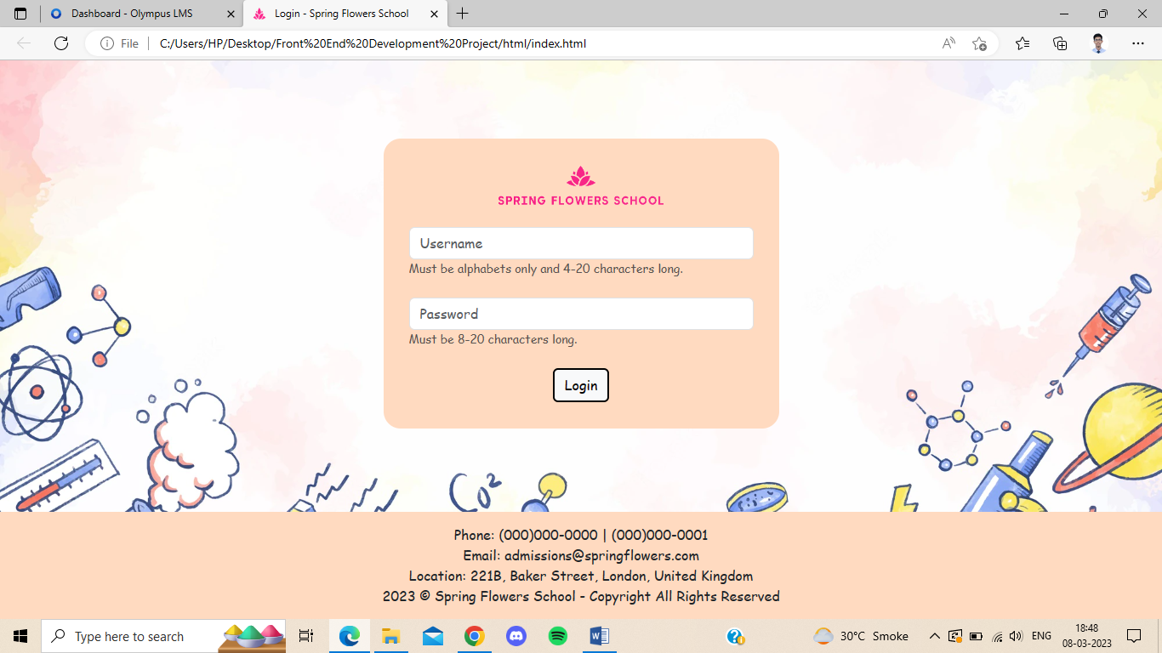

Home page:-

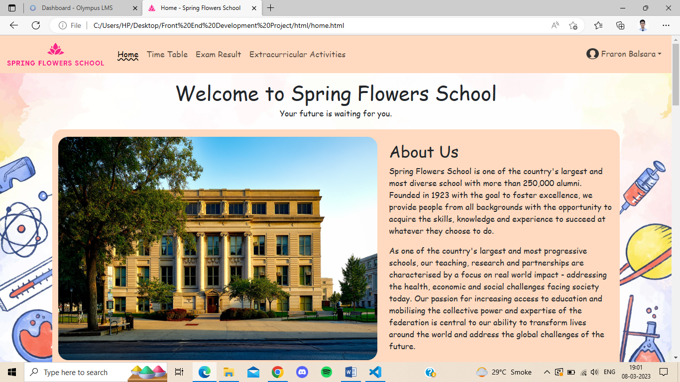

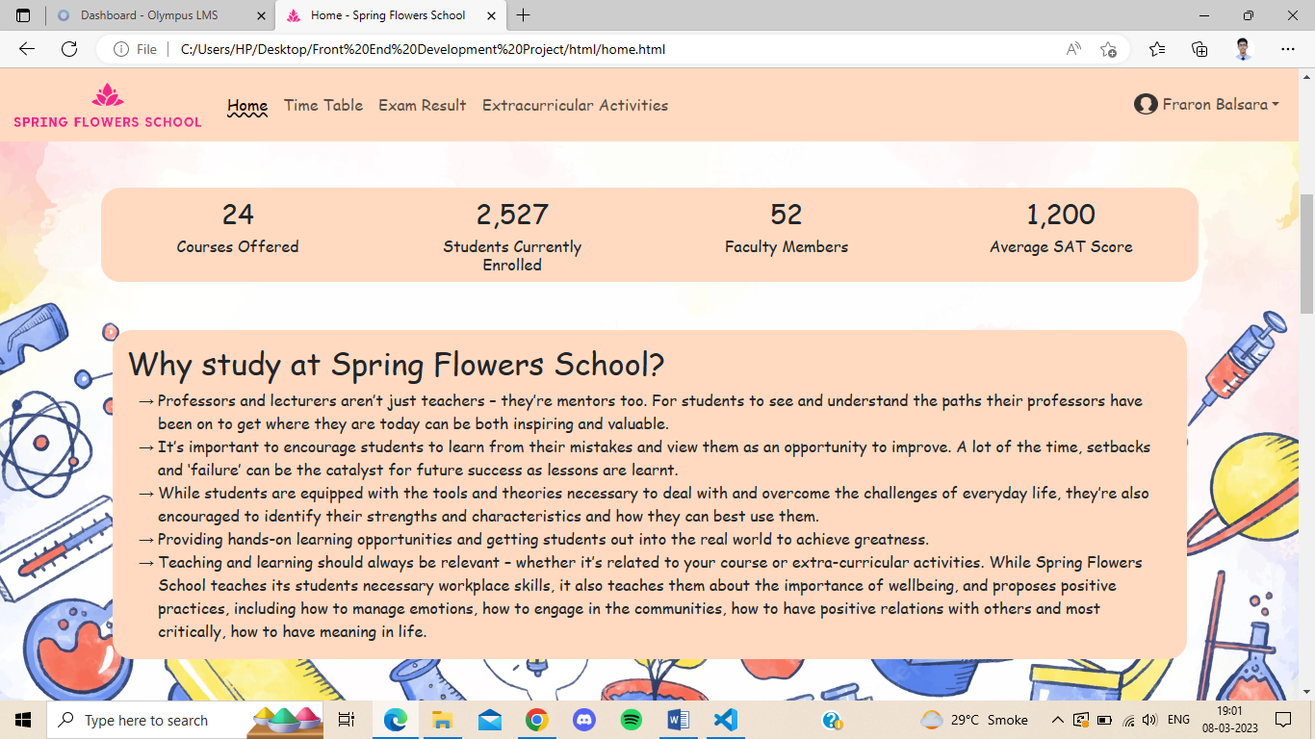

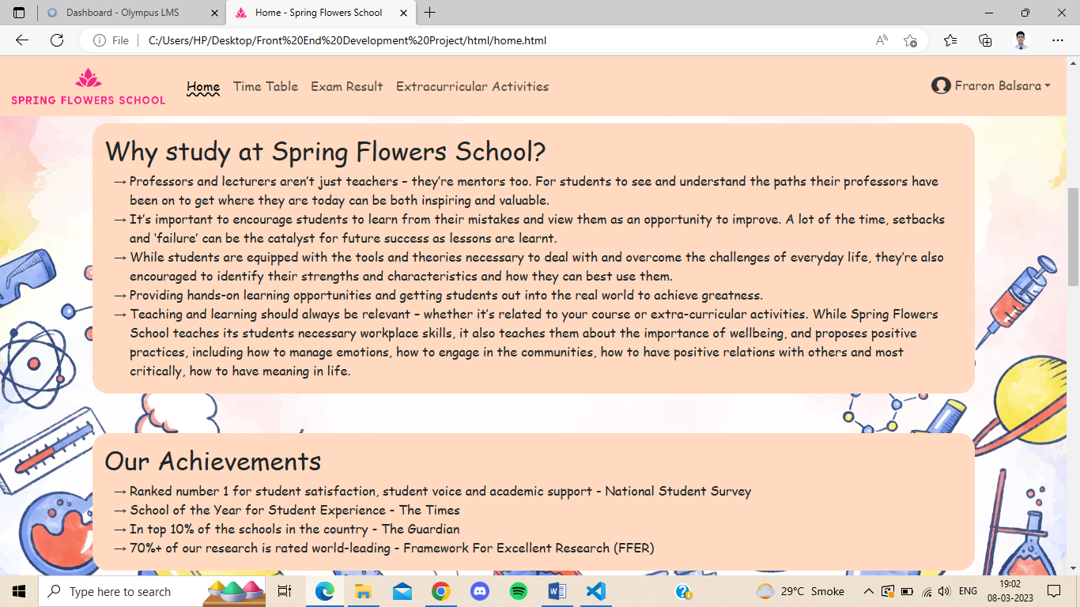

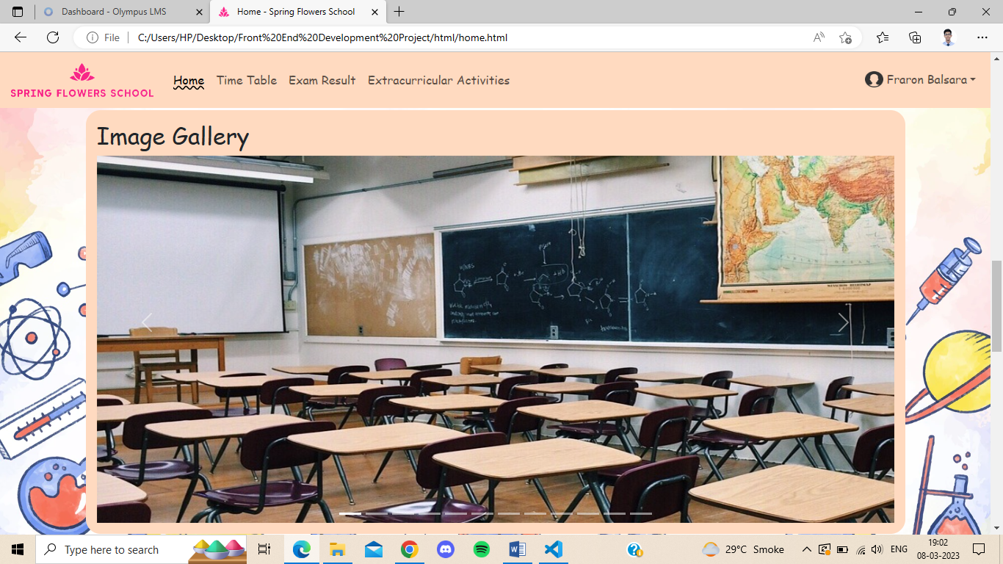

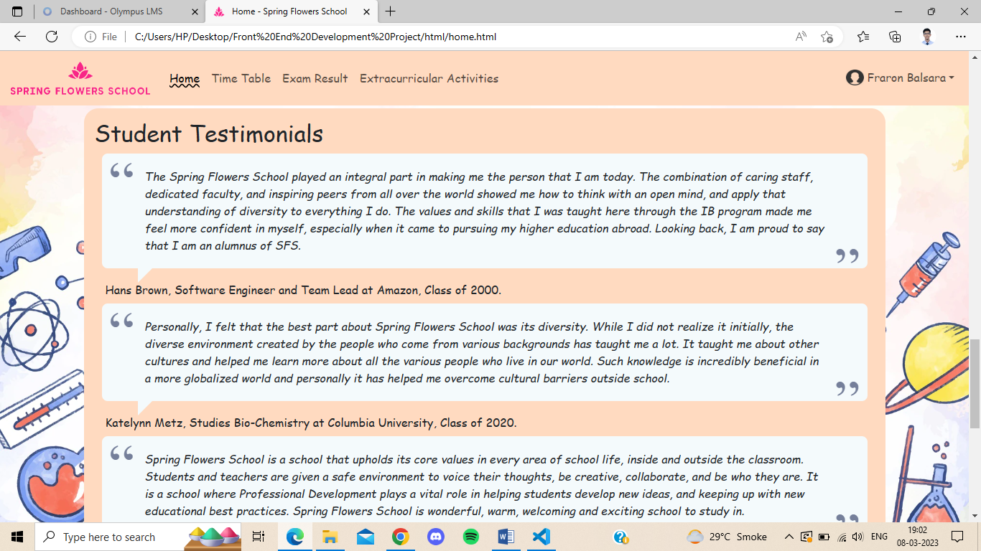

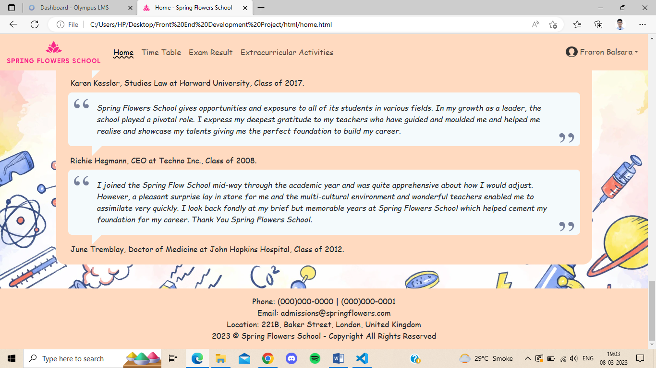

Time Table page:-

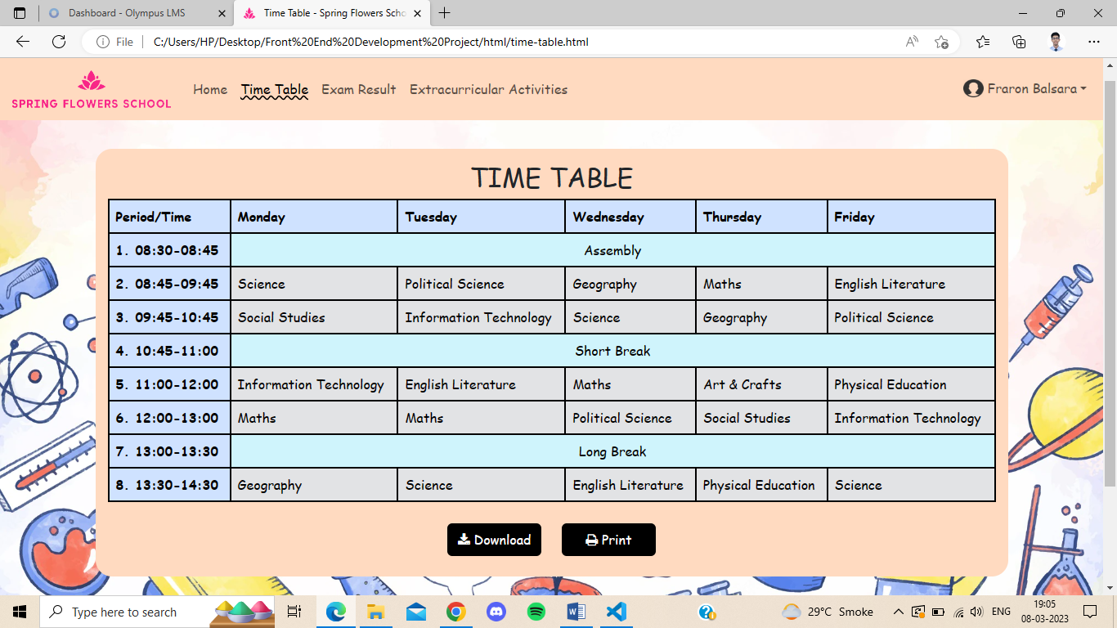

Exam Results:-

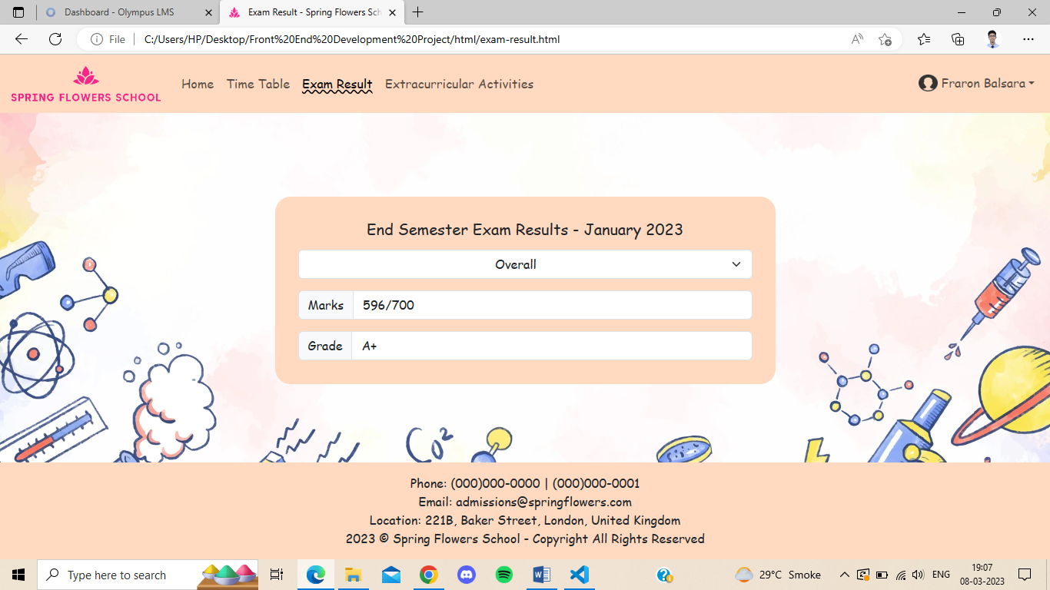

Extracurricular Activities:-

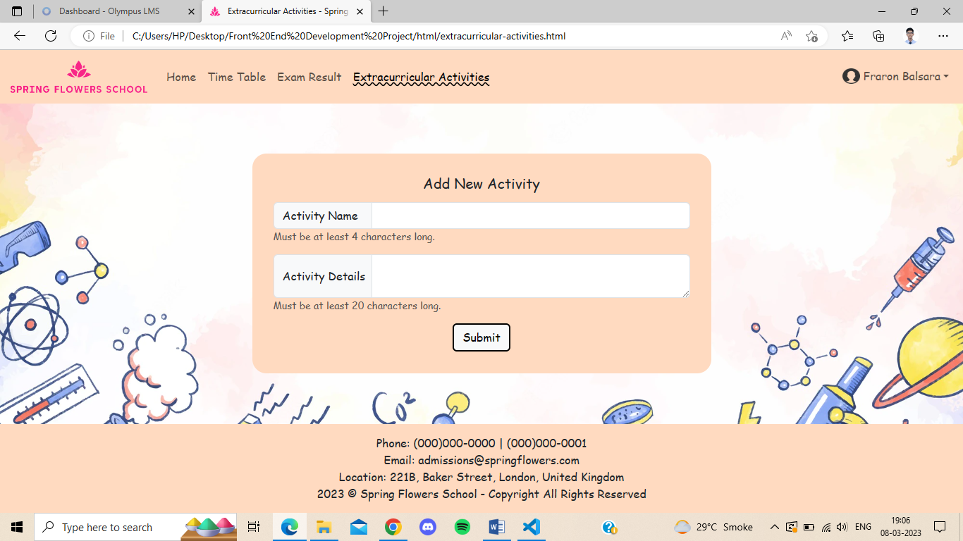

Profile Page:-

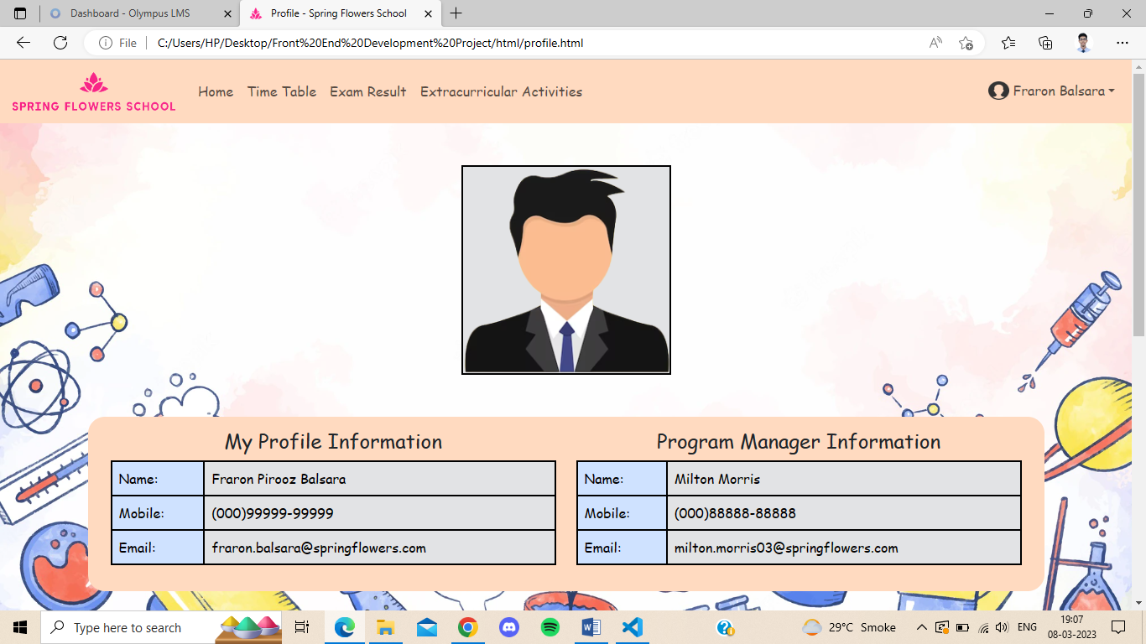

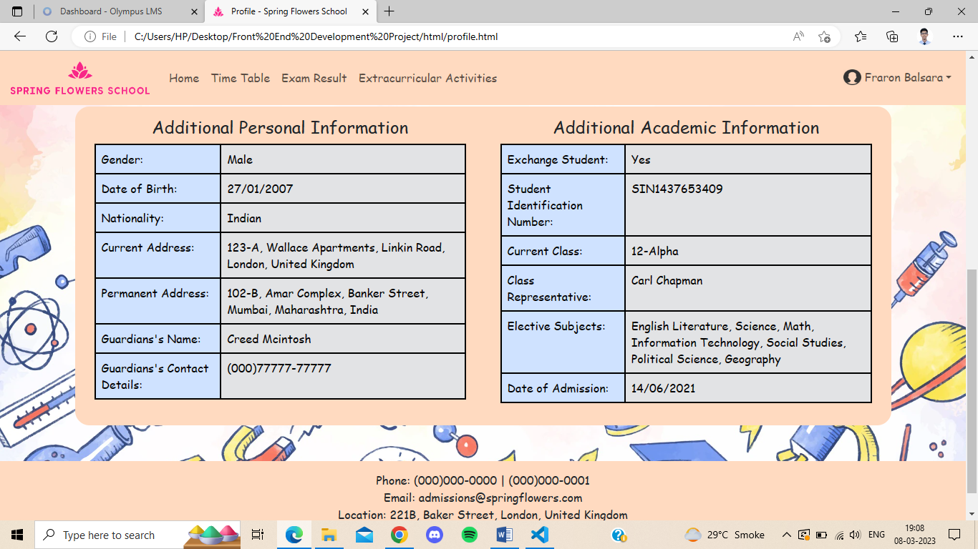

# **VALIDATION**

index.html (Login page):-

1. Username (min 4 character, max 20 characters, only alphabets and space allowed, no leading space)
   1. “John” – Valid
   2. “John Doe” – Valid
   3. “John Doe 112” – Invalid
   4. “John@Doe” – Invalid
   5. “Doe” – Invalid
   6. “twentylettersormorewillresultinaninvalidname” – Invalid
2. Password (min 8 character, max 20 characters, all characters are allowed)
   1. “eightlettersormore” – Valid
   2. “four” – Invalid
   3. “twentylettersormorewillresultinaninvalidpassword” – Invalid

extracurricular-activities.html (Extracurricular Activities page):-

1. Activity Name (min 4 characters, max 20 characters, all characters are allowed)
   1. “Cricket” – Valid
   2. “FTB” – Invalid
2. Activity Details (min 20 characters, max 1000 characters, all characters are allowed)
   1. “Cricket is widely played across India. It is the most popular sport in India.” – Valid
   2. “Cricket is a sport” – Invalid

# **CONCLUSION**

The Front-End Development Project was successfully completed. A web application was created for Spring Flowers School with a home page, exam results page, time table page, extracurricular activities page and a student profile page.

All users can access the home page and familiarise themselves with the school, its facilities and its culture by simply launching the web application on a browser. Additionally, it simplifies day to day processes for students already registered with the school. Students do not need to queue outside the school office for hours anymore and can view their time table and exam results directly on the website itself. The student profile section helps registered students view their personal information that is stored with the school.

The web application is user friendly and flexible. It allows instant access to school information through any electronic device with an internet connection. The web application is also responsive i.e. it adjusts to different screen sizes automatically and can be accessed from any device.

This web application will help Spring Flowers School achieve faster access to desired information, simplification of day to day processes, improved productivity, optimum utilization of resources and immediate access to desired information from anywhere at any time.

# **REFERENCES AND BIBLIOGRAPHY**

Author: w3schools

Title: HTML Tutorial

URL: <https://www.w3schools.com/html/default.asp>

Author: w3schools

Title: CSS Tutorial

URL: <https://www.w3schools.com/css/default.asp>

Author: w3schools

Title: JavaScript Tutorial

URL: <https://www.w3schools.com/js/default.asp>

Author: Bootstrap

Title: Get started with Bootstrap

URL: <https://getbootstrap.com/docs/5.3/getting-started/introduction/>

Author: Stack Overflow

Title: Stack Overflow – Where developers learn, share and build careers

URL: <https://stackoverflow.com/>

Author: Jeremy Caris on CodePen

Title: Responsive Testimonial Quote Example

URL: <https://codepen.io/jeremycaris/pen/zYOorR>

Author: Pixaby

Title: 2.7 million+ Stunning Free Images to Use Anywhere - Pixabay – Pixabay

URL: <https://pixabay.com/>

Author: Pexels

Title: Free Stock Photos, Royalty Free Stock Images & Copyright Free Pictures · Pexels

URL: <https://www.pexels.com/>

Author: freepik

Title: Free Vectors, Stock Photos &amp; PSD Downloads | Freepik

URL: <https://www.freepik.com/>

Author: cloudconvert

Title: CloudConvert

URL: <https://cloudconvert.com/>

Author: removebg

Title: Remove Background from Image – remove.bg

URL: <https://www.remove.bg/>